FishPath Tool User Guide

The Nature Conservancy

Last updated: June 30, 2020

# 

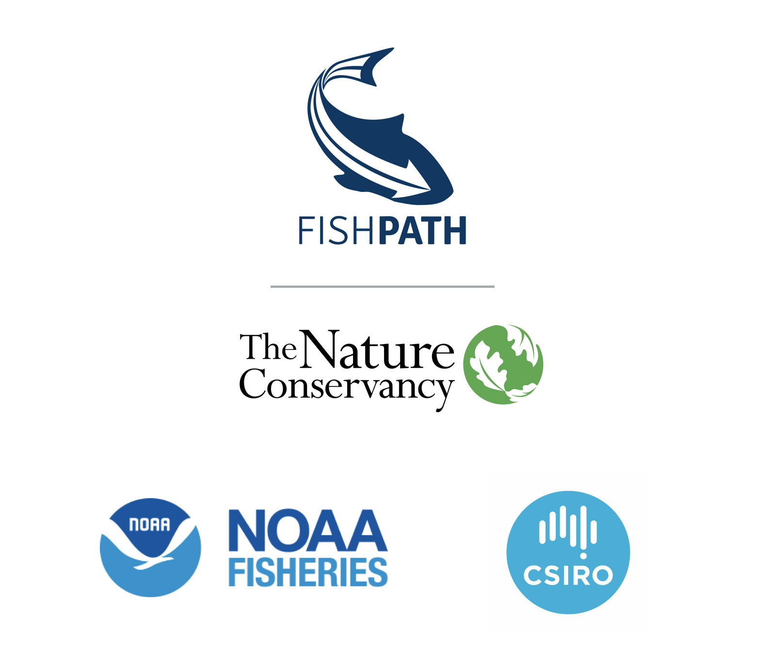

# Introduction

## Motivation for Developing the FishPath Tool and FishPath Process

Sustainable fisheries management tends to be underpinned by harvest strategies that specify a predefined relationship among data collection programs, assessment methods, and management measures. However, only a small fraction of the world’s fisheries has these management systems in place, with resource- and data-limited fisheries facing significant challenges in their development. Notable recent progress has been achieved in the development of stock assessments and other data-limited tools, but outstanding challenges for data-limited fisheries lie in developing fully articulated harvest strategies, which includes determining, linking, and implementing appropriate options. Understanding the full suite of available data collection, stock assessment, and management measure options and choosing the options most appropriate for each fishery is an often-daunting process, given the full landscape of options. Exacerbating the challenge of numerous options, data-limited fisheries are often simultaneously capacity-limited. In addition, small-scale fisheries have unique characteristics and challenges, requiring unique and tailored plans, and where “silver bullet” approaches that do not fully consider the entire fishery’s unique challenges must be avoided. An enormous challenge lies in making fisheries technical information, resources, and harvest strategy support tools accessible, simple, and structured, while not oversimplifying the innate complexity and nuanced aspects of each individual fishery setting as to the detriment of the fishery and fishery participants.

FishPath was developed as a collaboration between The Nature Conservancy (TNC), the U.S. National Oceanic and Atmospheric Administration (NOAA), and Australia’s Commonwealth Scientific and Industrial Research Organisation (CSIRO). FishPath is an approach for setting fisheries on the path to sustainability. The FishPath approach is something that everyone working in fisheries tries to do anyway — try and figure out what to do with what you have. It is simply a highly organized and inclusive way to do it and should be the entry point of any fisheries management development.

FishPath includes a stakeholder engagement process which is underpinned by the FishPath tool. The FishPath process aims to engage stakeholders and build capacity to develop predefined fisheries harvest strategies that are tailored to local conditions and challenges. The FishPath tool supports the process of narrowing down and identifying viable components of the management strategy. However, the FishPath tool, while providing advice on narrowing the viable list of harvest strategy options, does not make the final selection or articulate the details of, evaluate, and implement the harvest strategy. It is strongly encouraged that users work with trained facilitators from the FishPath Network to facilitate this process and use resources found within the FishPath tool that identify appropriate tools for carrying out the harvest strategy.

## FishPath Tool Overview

The FishPath tool is an online decision-support tool that streamlines the process for identifying options for the 3 central components of a harvest strategy, specifically, the appropriate options for data collection programs, stock assessments, and management measures (or harvest control rules). The FishPath Tool Platform is a web-based software tool that is developed using Javascript and the React-Redux framework. It is hosted on Amazon Web Services (AWS) servers.

To do this, FishPath tool users answer a series of multiple-choice questions regarding social, economic, operational, biological, ecological and governance characteristics of the fishery, including available data. User responses then flag key assumptions, considerations, and cautions for each option contained in the FishPath tool, which provides customized advice on the appropriateness of any option for the fishery of interest. The results section provides a guided process for narrowing down available options to a short list to be more formally considered for inclusion in a harvest strategy (Figure 1). Users can also learn about each option through details, resources and links within the tool.

It is important to understand what the FishPath tool does and does not do. First, the FishPath tool is not quantitative – it does not input, upload, or analyze data. The FishPath tool does not use an underlying model and is not a simulation or stock assessment tool. The FishPath tool does aid in the process of identifying a short list of viable options, but it does not prescribe a single, preferred option for each harvest strategy component. Rather, it encourages critical evaluation of an identified subset of options. The FishPath tool provides a standardized, transparent, and efficient platform for users to build the foundation of a harvest strategy for data-limited fisheries. The FishPath tool content undergoes continual updates to include the latest fisheries science and practitioner information. FishPath tool users may submit content suggestions at [support@fishpath.org](mailto:support@fishpath.org).

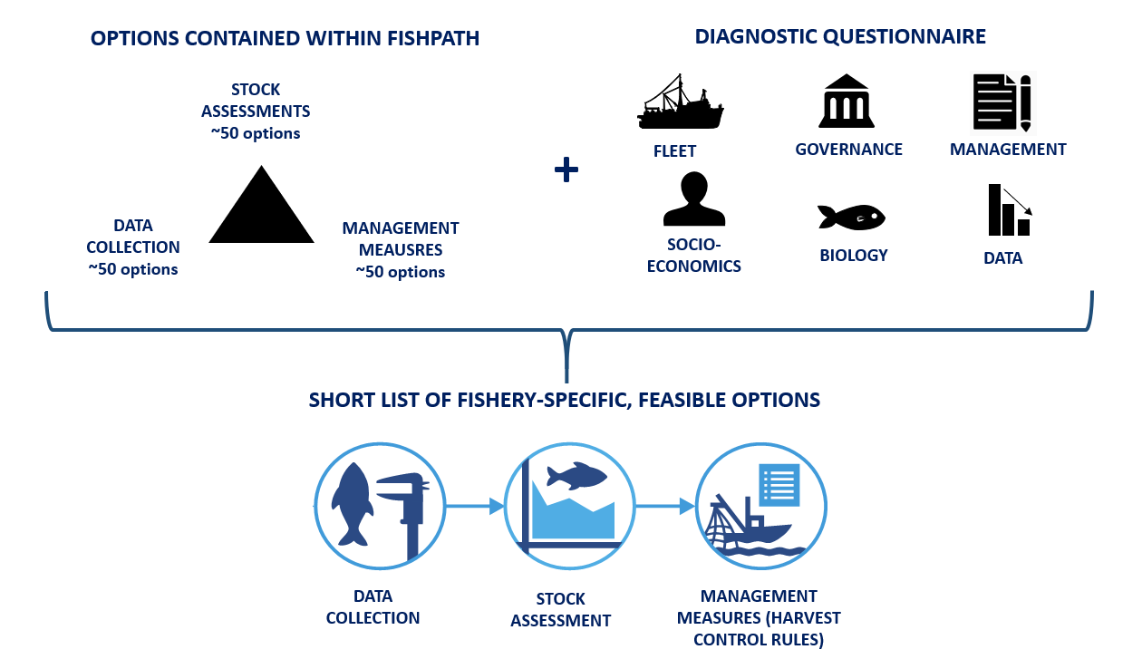

Figure 1: The FishPath tool at a glance.

## Purpose and Intended Audience of the FishPath Tool User Guide

The purpose of the FishPath Tool User Guide is to orient users to the FishPath tool, explain the functionality of tool features, and provide succinct guidance on how to use the FishPath tool to select and review appropriate harvest strategy options. The ultimate goal of using the FishPath Tool is to support the development of an articulated harvest strategy for use in a Fishery Management Plan (this process is outside the scope of the FishPath Tool User Guide).

The FishPath tool is applicable in a variety of settings. Examples include: use of the FishPath tool in a facilitated, multi-stakeholder workshop setting; small expert groups; individual (“desktop”) use for harvest strategy development or review; or research related to individual components of a harvest strategy, such as selection of an assessment method or details about specific data collection or management measure options. The impact of the tool greatly depends on the context it is used, being most effective in a multi-stakeholder process and lead by experienced practitioners. The use of the tool can also be adapted to work with multi-species fisheries, multi-fleet fisheries, and in selecting current and future scenarios. Guidance on using the tool in these contexts will be incorporated into future versions of the user guide.

# Starting the FishPath Tool

Importantly, the FishPath tool requires a consistent internet connection to access the questionnaire, save answers, and interact with results.

## Welcome Page

When a user navigates to <https://tool.fishpath.org/>, a welcome page is displayed with two prompts: “Create an Account” or “Login” (Figure 2).

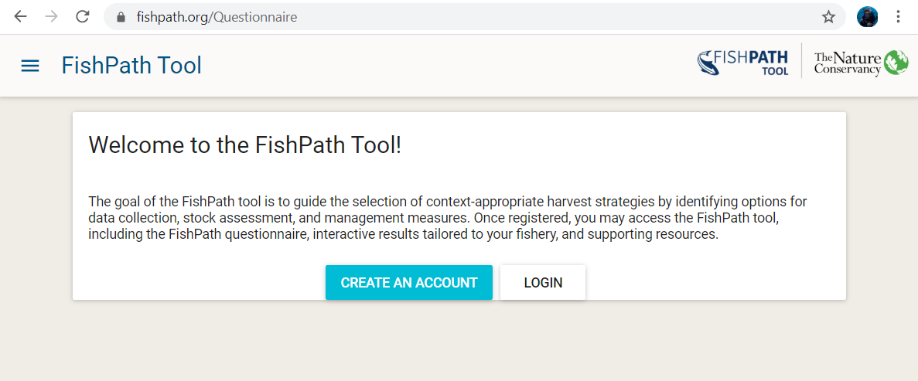

Figure 2: Welcome page of the FishPath tool.

## Creating a FishPath Account

Upon selecting “Create an Account”, a pop-up window appears with the following fill-in fields (Figure 3). An asterisk denotes mandatory information.

* Email*
* Password* (create a password)
* Organization Type*
* Organization
* Your Name*
* Country*

Note that the email and password fields are case sensitive.

This information is used to track user origin and the use of the FishPath tool. At this account creation stage, the user is also prompted to read and accept the Terms of Service of the FishPath tool, developed by The Nature Conservancy (Appendix B).

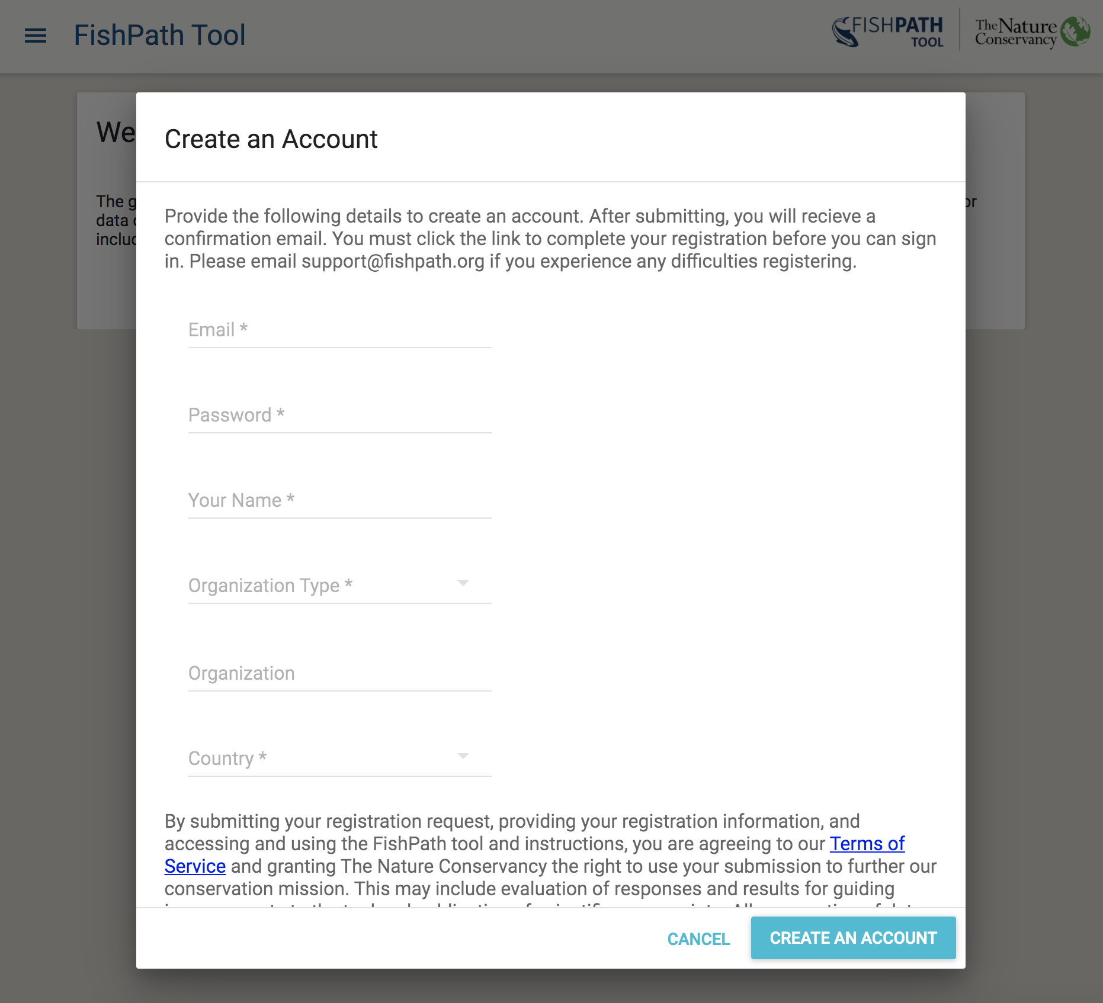

Figure 3: “Create an Account” screen of the FishPath tool.

After submitting the account request, the user will receive a confirmation email with a link to complete registration. After account creation, whenever the user returns to the Welcome Page of the FishPath tool, the user may simply “Login” with their email address and password (Figure 4).

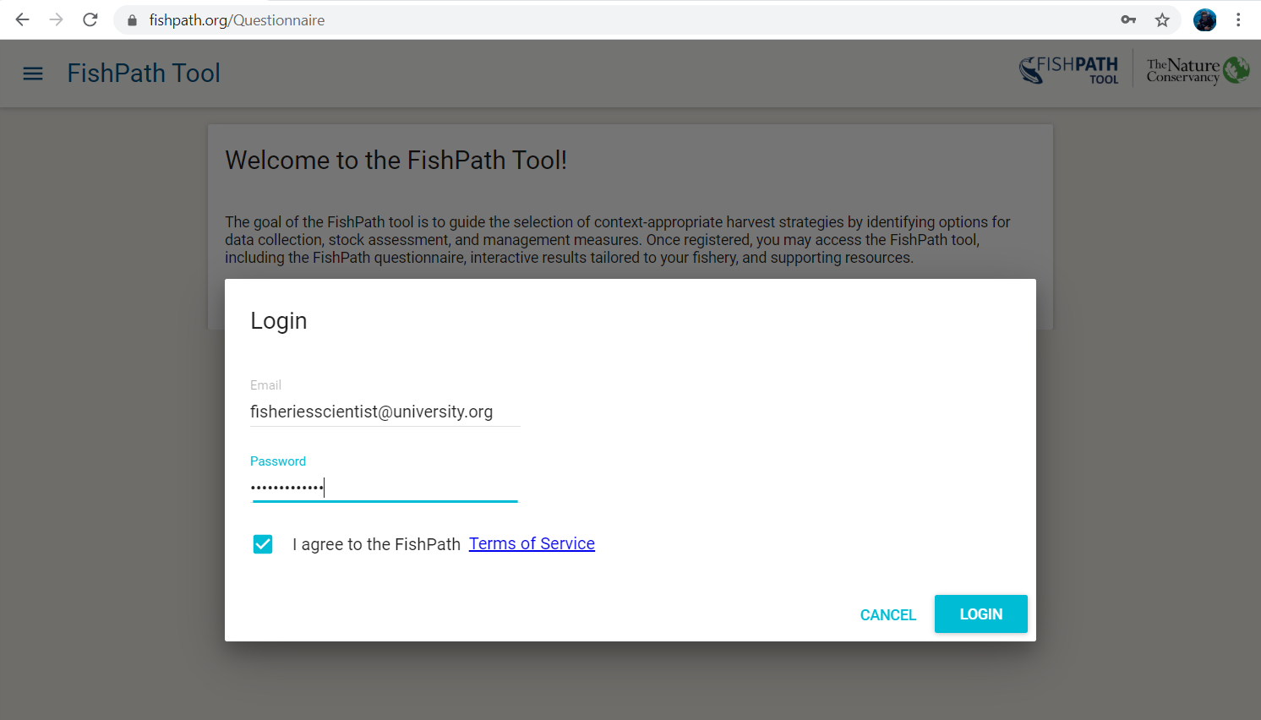

Figure 4: Login Page of the FishPath tool.

## FishPath Tool Dashboard

After creating an account (new user) or logging in (existing user), the user is directed to the FishPath Tool Dashboard (Figure 5), or the user’s “homepage” of the FishPath Tool. On the FishPath Tool Dashboard, users view 4 headings:

1. **“FishPath Tool User Guide”**, which contains detail on using the FishPath Tool and interpreting results.
2. **“My Fisheries”**, which provides a list of the user’s current list of fisheries they have started or completed in the tool. Users may access their fisheries at any time through this section, and return to in-progress FishPath questionnaires or results pages;
3. **“Reference Materials”**, which provides a list of all options contained in the FishPath tool with details and reference materials;
4. **“Get Support, Ask a Question, or Help us Improve the FishPath Tool”**, which allows the user to send questions or feedback to the FishPath team.

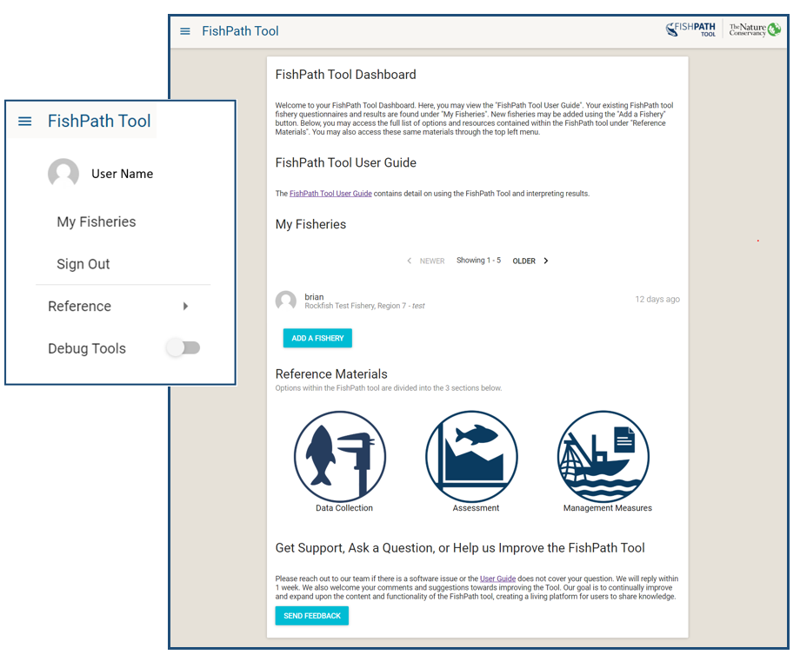

Figure 5: FishPath Tool Dashboard, or the homepage for FishPath tool users. The pop out shows the FishPath Tool Dashboard drop-down menu.

When a user clicks the “FishPath Tool” menu in the top left corner, a drop-down display allows the user to navigate to various options (Figure 5). The “Reference Materials” tab displays all of the options contained in the FishPath Tool.

## Adding a New Fishery

Selecting the blue button “Add a Fishery” allows users to start a new fishery in the FishPath tool that will be added to their account. First, a pop-up “Fishery Information” screen appears to prompt users to define the fishery of focus (Figure 6), using the fields below. This information is used to better understand the use of the FishPath tool, provide high-level aggregate information about fishery characteristics, and to help users define the fishery to which they will be applying FishPath, so that answers will be directed at that fishery only.

* Fishery Common Name(s):
* Genus species:
* Fleet and Gear Type(s):
* Country or Countries:
* Geographic Area of the Fishery:
* In which of these 3 contexts is the FishPath Tool being used for this fishery?
  + Exploratory test run
  + Facilitated workshop for specific fishery
  + Individual use for specific fishery

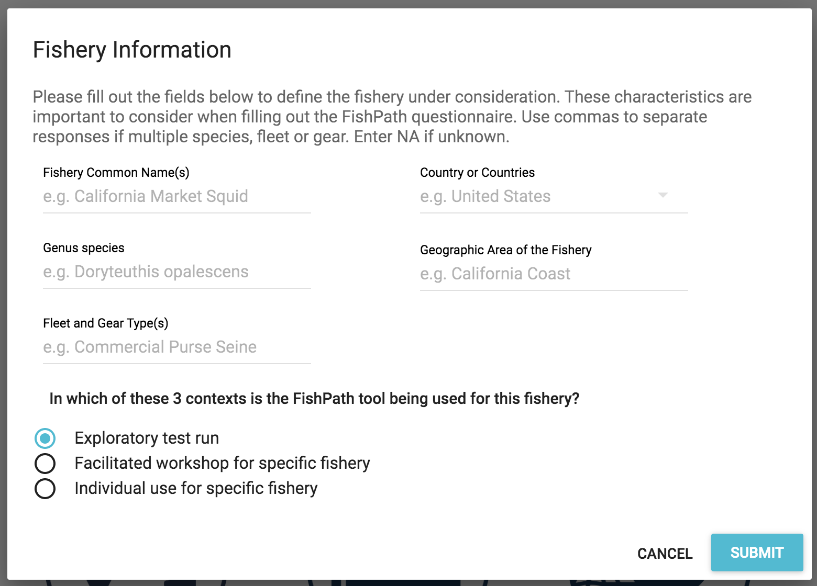

Figure 6: Fishery Information pop-up screen of the FishPath Tool.

Upon selecting “Submit”, the user is prompted to select one of the 3 harvest strategy components (sections) of the FishPath Tool (Data Collection, Assessment, Management Measures) and begin the FishPath tool questionnaire (Figure 7). Users can complete and review results from these sections independently. A pencil in the upper-right corner allows users to edit the fishery information (input in Figure 7) at any time.

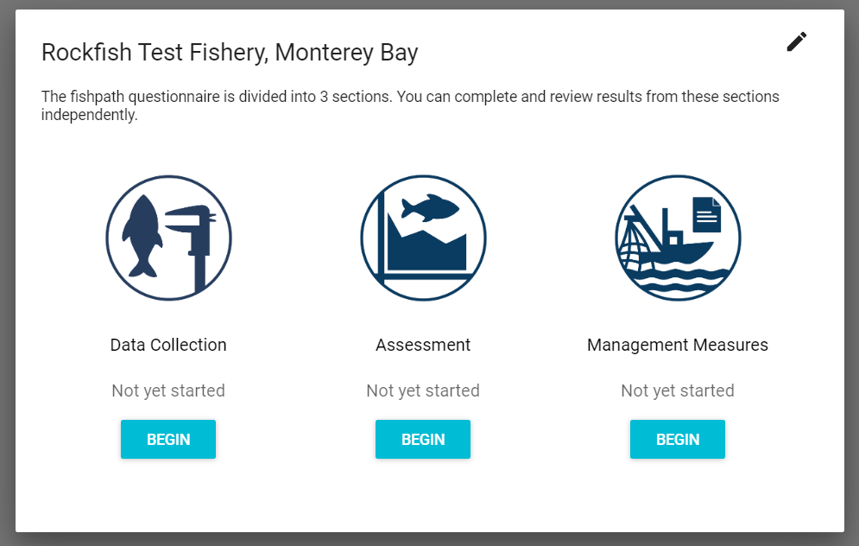

Figure 7: Entry screen to the FishPath tool questionnaire after fishery information has been defined.

# FishPath Tool Questionnaire

The goal of the FishPath tool questionnaire is to elicit information about all aspects of the fishery. This information leads to the activation of assumptions, cautions and considerations for each option. Across the three sections (Data Collection, Assessment, and Management Measures) the user answers a series of ~120 questions. Questions are categorized in 6 categories, which indicate the nature of the information in the question:

1. Biology/Life History
2. Data Availability
3. Governance
4. Management
5. Operational Characteristics
6. Socio-Economic

Some questions span multiple sections of the questionnaire (i.e. they are relevant in considering multiple components of a harvest strategy). To avoid duplicity, such questions, once answered, will show as completed when beginning any subsequent section in which they occur.

At any time, the user may close and later return to their session via their “My Fisheries” dashboard. Any submitted answers will be saved with a consistent internet connection. Once the user has completed an individual section, which may only be achieved by providing responses to all questions in that section, the user may either complete a subsequent section or view results from the completed section. Results for any section become available once the user has completed the respective questionnaire. The questionnaire is periodically updated by the FishPath team to reflect the latest fisheries science, so users may need to answer any new questions when returning to a fishery before reviewing results of associated sections.

After viewing the entry screen to the FishPath questionnaire (Figure 7), the user selects one of the 3 sections. An overview screen will appear with the name of the section, the number of questions associated with that section, and a short guidance on answering the questions (Figure 8). The user can then choose to “Begin” the section or “Choose Another Section”.

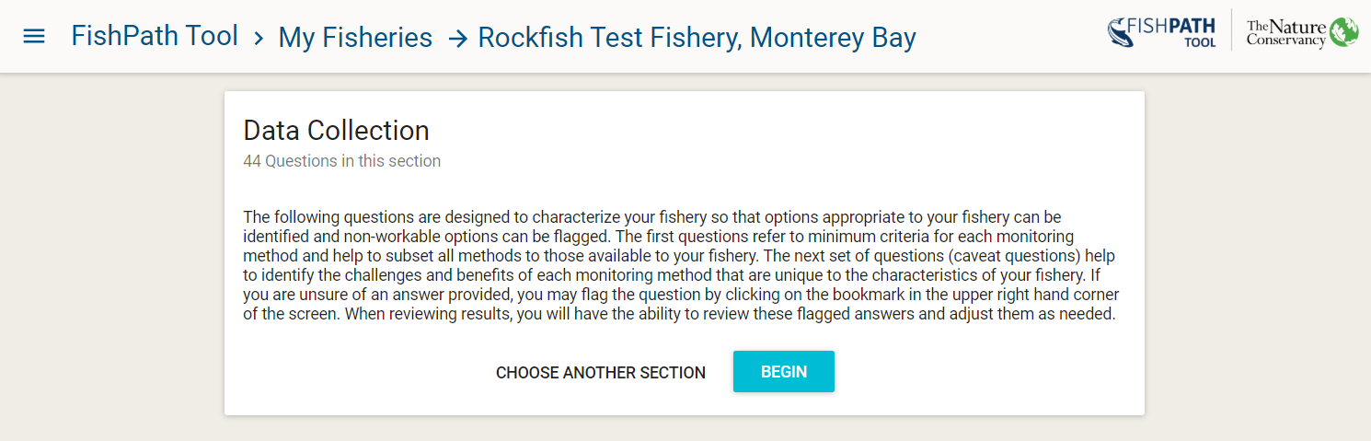

Figure 8: Data Collection section overview.

## Criteria and Caveat Questions

In the FishPath tool, questions are designated as either “Criteria” or “Caveats” or both, which refers to how question responses are linked to options contained within FishPath.

A Criterion question is used to determine whether the fishery meets a minimum qualification required to apply an option. Whether the fishery meets the minimum (or often multiple) criteria for each option is indicated in the results window (see Results sections below). For example, in the “Assessment” section of the questionnaire, there are questions about data quality, quantity, and data type for the fishery, which correspond to the minimum levels required to enable each type of assessment method. Upon answering a “criteria question” about, for example, fishing effort data, within the Assessment section (Figure 9), the fishery will be scored in the results section according to whether it meets that particular minimum level of effort data required by particular assessment options. The Results section reports not only whether or not each criterion is met, but also gives an indication, via subjectively assigned traffic light color scales, as to the degree the criteria is met, and provides guidance as to the level of uncertainty associated with that particular required input. Criteria questions are not included in the “Management Measures” section. While a management measure option may be ill-advised because it violates assumptions (i.e, “caveats”), there are no prohibiting factors that would prevent any single option being implemented, if so desired. Conversely, one cannot undertake certain assessments or forms of data collection without meeting minimum requirements.

Questions whose responses invoke “caveats” will not eliminate or retain options, but rather invoke subjectively assigned traffic light-colored warnings, or positive attributes, against specific options. These are intended to speak to issues that do not necessarily prohibit the option’s feasibility, but that should be given explicit consideration, and the ability to address each should be determined, before deeming the option is best suited to the fishery. As with the criteria questions, these are presented in the results section of the FishPath tool with explanatory text.

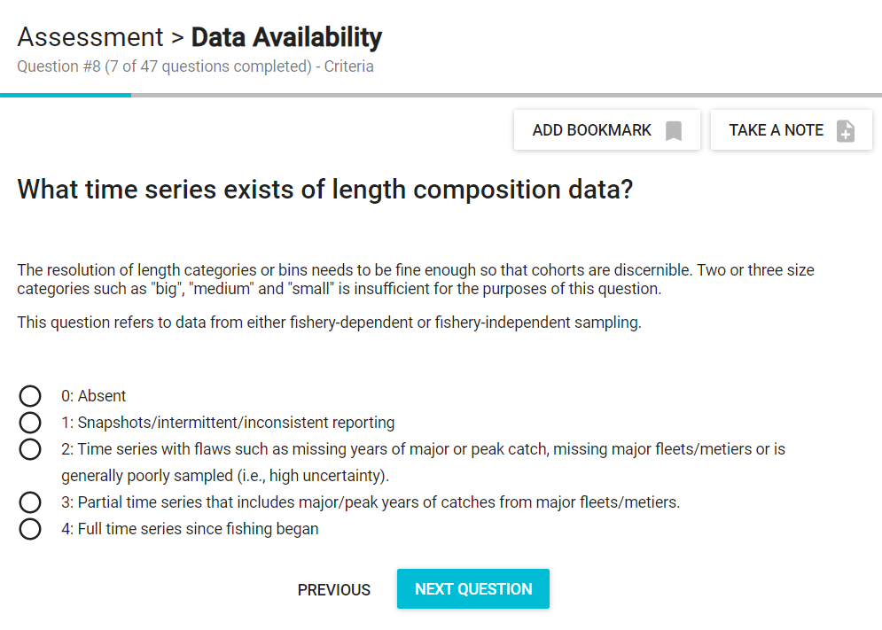

Figure 9: Example “criteria” question in the Assessment section of the FishPath Questionnaire.

## Anatomy of a FishPath Tool Question

(Figure 10) provides an example of a FishPath question screen:

1. At the top of the screen, the **section** is shown (either Data Collection, Assessments, or Management Measures).
2. The section is followed by the **question category** (i.e., Biology/Life History, Data Availability, Governance, Management, Operational Characteristics, or Socio-Economic).
3. A sub-heading identifies whether the question is a **“criteria” or a “caveat”** question.
4. The sub-heading also indicates the **number of questions answered** and remaining within that section.
5. For the Data Collection section only, it is also stated whether the question pertains to either issues of **“representation” or “implementation”**. This helps users to understand the intent of the question, by identifying whether the question has ramifications for the form of data collection in terms of its either ability to obtain representative data, or in its ability to be effectively implemented.
6. There is the ability to **“Bookmark”** the question. A bookmark flags questions for ease of later revisiting (Figure 11). A question may be bookmarked for reasons such as if the answer is unknown, it needs further consideration or input, is in dispute, or if the user feels the question is critical. As all questions must be answered in order to review results, adding a bookmark allows users to provide an interim response that may be revisited in the results section, once the user can evaluate the relative impact of their response.
7. Users can **“Take A Note”** on a question (Figure 11). Notes can be taken for a variety of reasons such as to clarify why a certain response was given, to capture important discussion had about a question, why the question was bookmarked or noting a response requiring further research. Notes can later form an important part of draft harvest strategy development, and, by providing justification for the response, can maintain traceability and replicability. When connected to the internet, all notes made will be saved into FishPath and available to the user for reference.
8. At the bottom of the screen, the user may advance to the **next question** or return to the **previous** question.

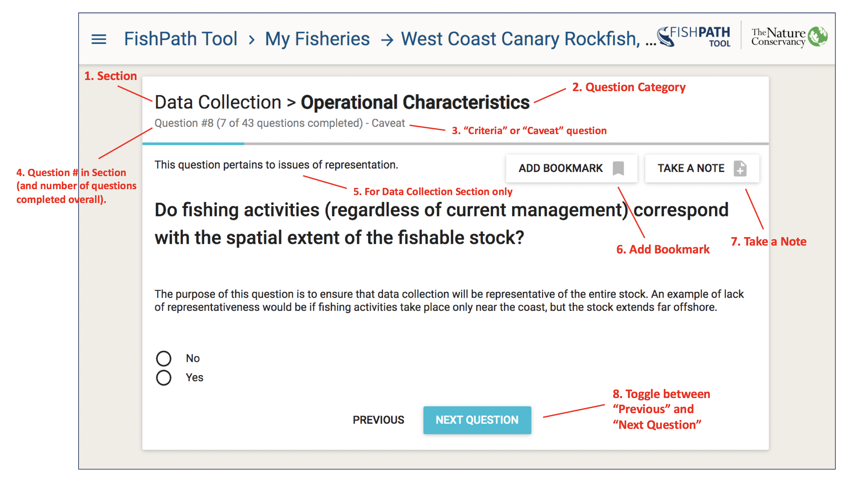

Figure 10: Anatomy of a FishPath tool question.

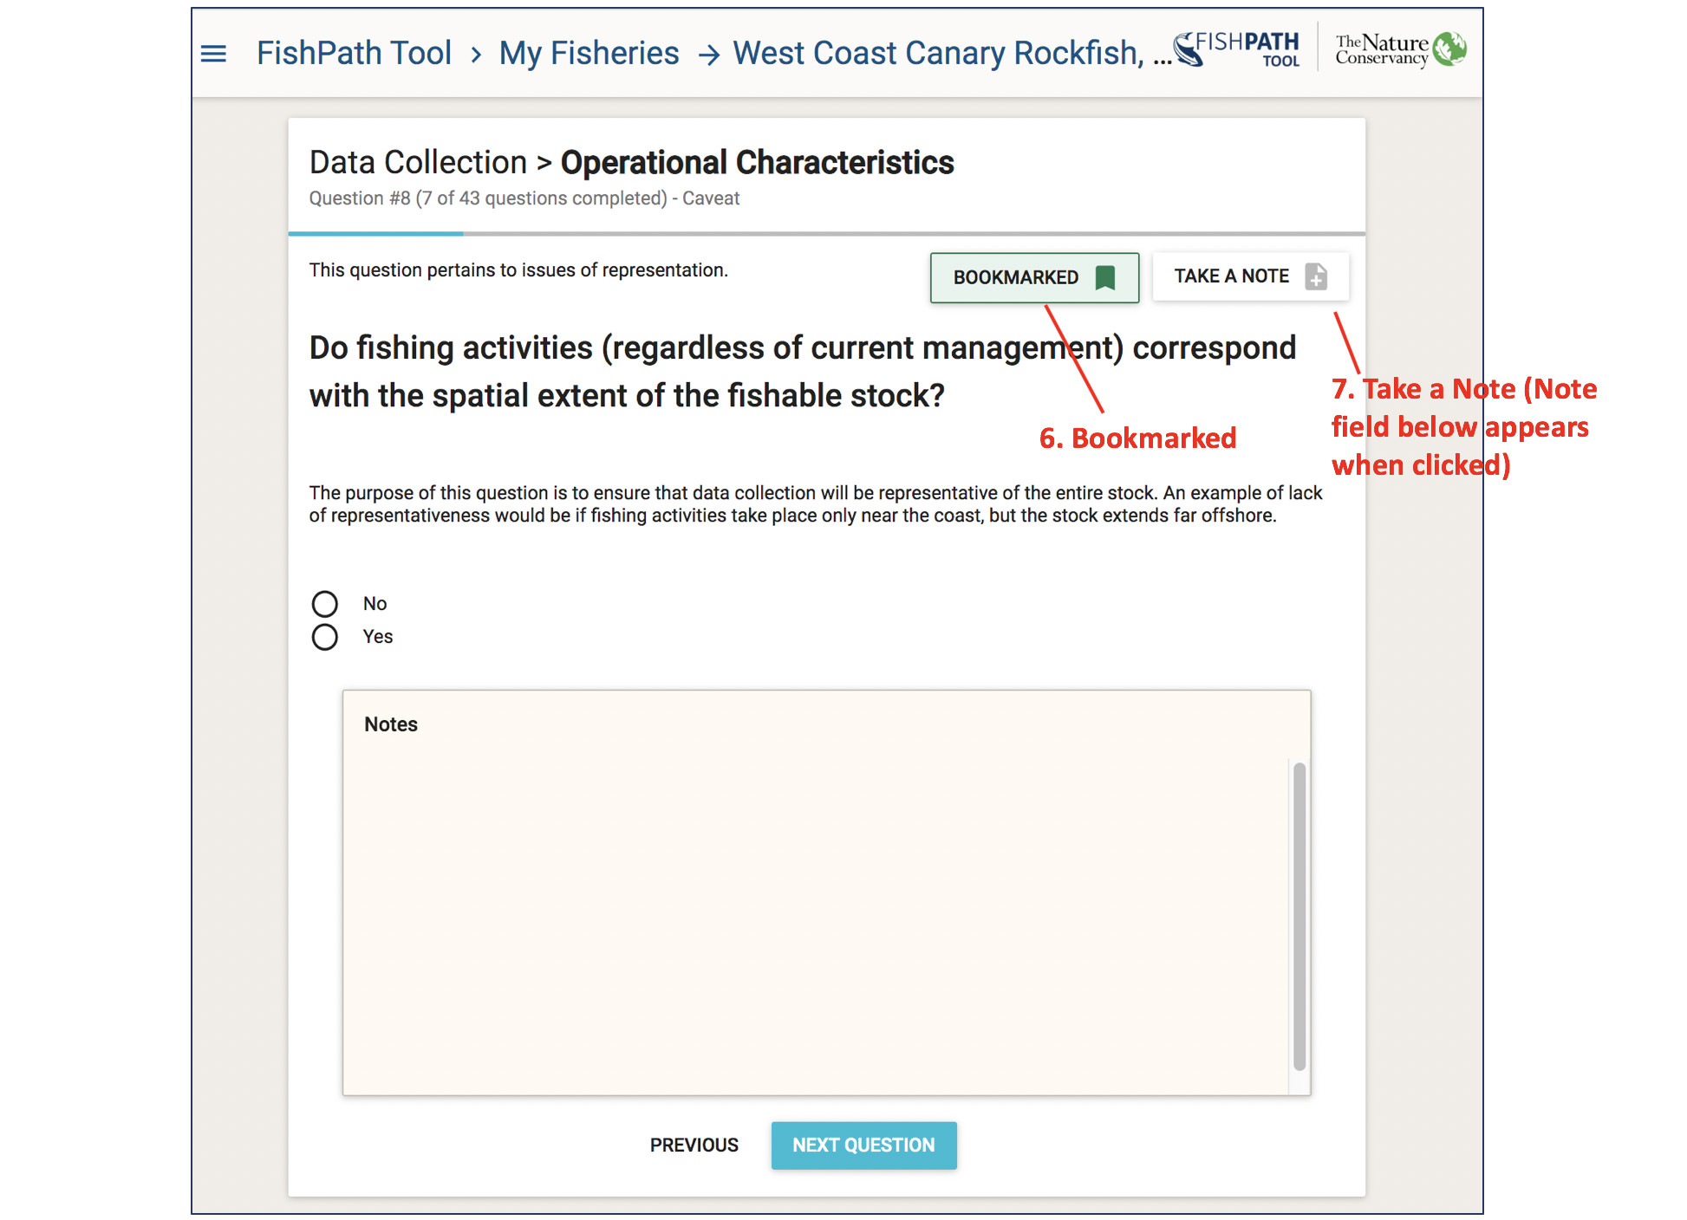

Figure 11: Example FishPath tool question with “Bookmark” (green) and “Take a note” (text box) functionality selected.

## Subjective Questions

While the majority of questions within FishPath are intended to be answered definitively (objective), certain questions are subjective in nature. The latter typically request a user response in the form of a perceived ranking (e.g. “low”, “moderate”, “high”). Most such questions invoke caveats and, when all caveats are considered together, the relative impact of those invoked by subjective questions can be evaluated. In this way, priority can be assigned to whether the response requires further consideration and debate, or whether it is of little relative significance in determining the most viable harvest strategy options. Further discussion can then be focused on the most appropriate issues.

Generally, the best approach to take when completing the questionnaire is to aim to do so relatively efficiently, without overtly laboring or debating over any one question. If in doubt, the question can be bookmarked, and notes can be taken, for easy revisiting later. The transparency of the FishPath tool is such that users will be able to see explicitly how their response to any one question influences the results (by invoking criteria or caveats), and to readily change their answer if so desired. Moreover, the aim of the questionnaire is to obtain an overall profile of the fishery’s characteristics, so as best to inform the choice of harvest strategy option. As such, questions may pertain to only a few options, or they may not invoke strong caveats. The goal is to appraise the fishery as a whole, as opposed to focusing on any single question.

## Completing the Questionnaire

Upon completing or exiting any of the three sections, a summary screen appears with the status of relative completion. Users review their result for completed sections, or otherwise continue the questionnaire (Figure 12).

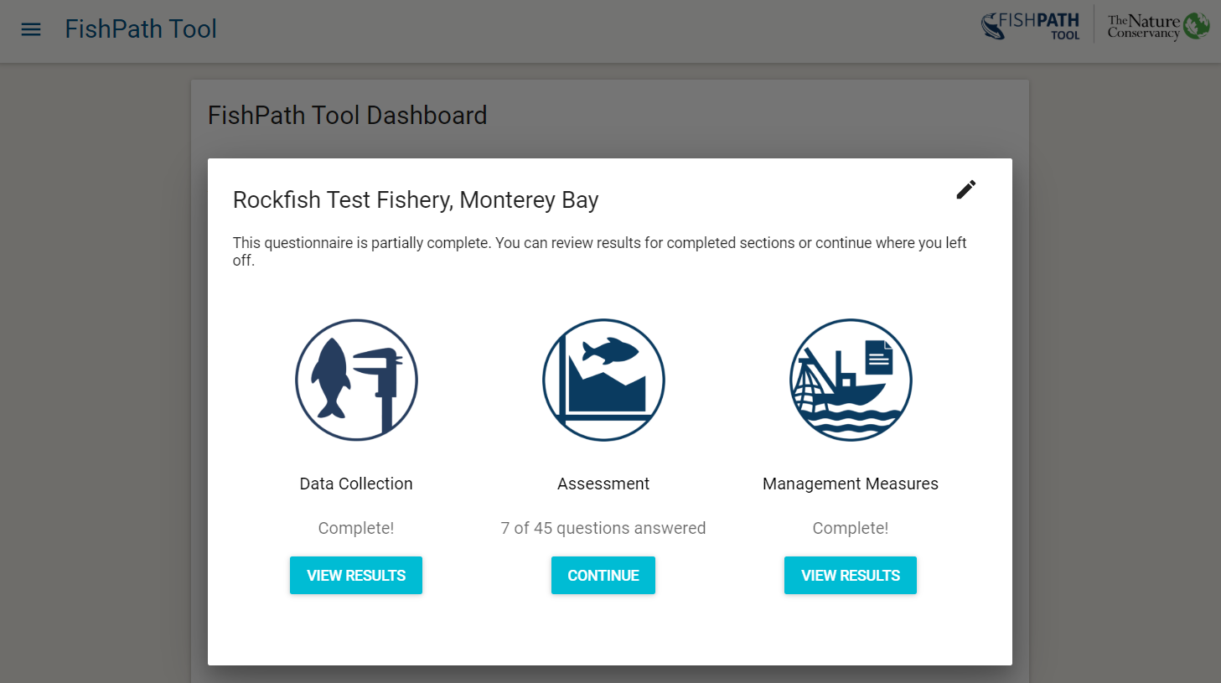

Figure 12: Summary window of the 3 FishPath questionnaire sections, showing questionnaire progress.

# FishPath Tool Interactive Results Page

The FishPath Tool Interactive Results Pages allow users to view and interact with all of the options contained within FishPath and understand how each option may apply to their fishery.

Upon completion of the questionnaire for any section, the user is directed to the FishPath Tool Interactive Results page (Figure 13). The results are presented separately for each of the 3 sections, or harvest strategy component: 1) Data Collection; 2) Assessment; and 3) Management Measures (Figure 13, sections shown in dark blue bars near top of screen).

Each of the three sections of the results can be accessed individually without needing to complete all three sections. If a user has not completed the questionnaire in at least one of the sections, they will be prompted to return to finish the section questionnaire before accessing results (Figure 12).

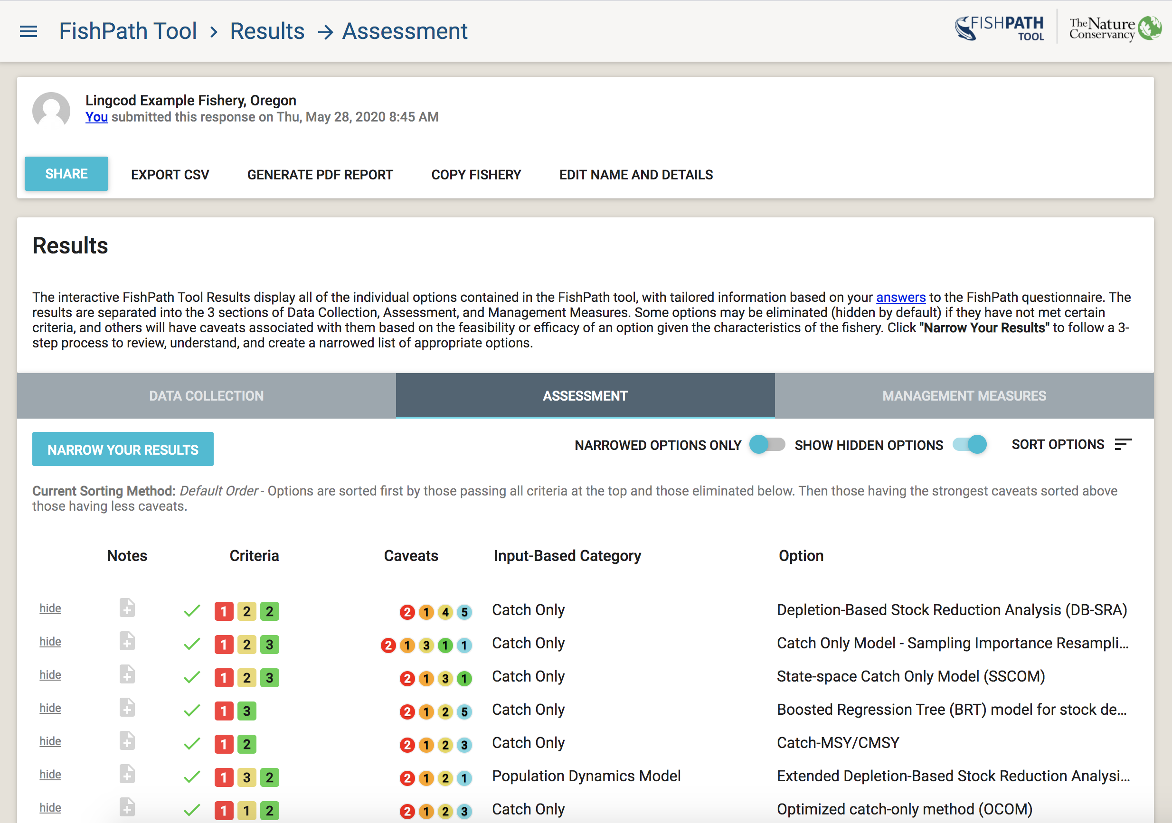

Figure 13: Initial results display screen in the FishPath tool (featuring the Assessment section), displaying a snapshot of results, not a full listing.

Figure 14 shows the general components of the results page. Each of these is elaborated below:

1. Actions to Share Results and Edit Fishery Info
2. Interactive Results Table
3. Show Hidden Options and Sort Options
4. Bookmarked Questions and Influential Answers
5. Results Narrowing Process

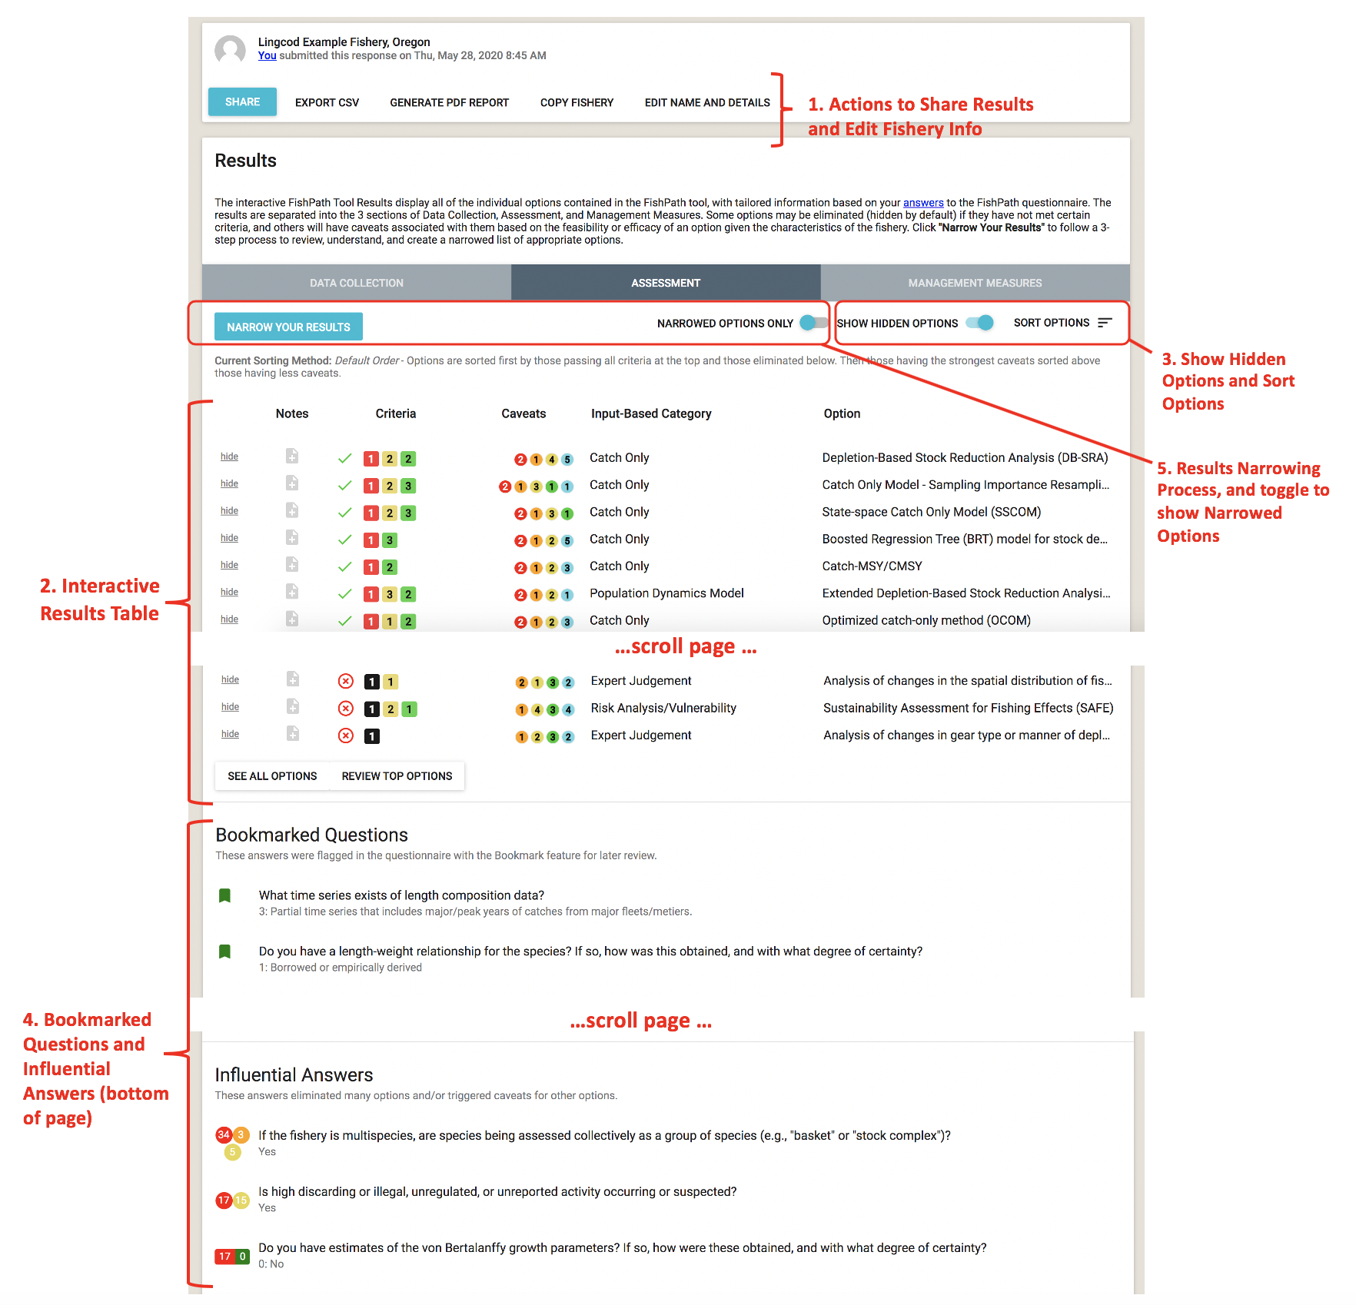

Figure 14: Key components (red labels 1-5) of the FishPath Interactive Tool Results Page.

## Actions to Share Results and Edit Fishery Info

At the top of the Results Page, the user may either “Share”, “Export CSV”, “Generate PDF Report”, “Copy”, or “Edit Name and Details” for their fishery (Figure 14).

* **Share:** This will generate a link that allows the user to share a fishery with someone. The user simply needs to send the link and the recipient will have view-only access to this fishery from their active account. A shared fishery can be saved under someone else’s FishPath account, and they can make a copy of it to separately edit, if needed. Tip: when creating a copy of a shared fishery in a user account, it is useful to rename the fishery so that edits are tracked under this new name.
* **Export CSV:** This allows users to export the question and answer list from the saved questionnaire, as well as a simple results file, as a .csv file.
* **Generate PDF Report:** Allows the user to create a .PDF of the FishPath results, with all notes captured. The PDF report provides detailed information on each option and their associated caveats and criteria related to the fishery. Users can select to see a report for the “full list” of options, or for a specified list of “top options”.
* **Copy Fishery:** This allows users to make a copy of a fishery’s results, be these their own, or from a shared link. To rename that fishery and edit it under a different name, the user should select the “Edit Name and Details” button.
* **Edit Name and Details:** This allows users to edit the information entered on the Fishery Information form (name, species, geography, etc.)

## Interactive Results Table

The results table lists all the available options for the section of interest in rows. Each row summarizes the criteria met and failed, and the caveats invoked (see also “Criteria and Caveat Questions” section above). Each option can be selected and expanded to view its description and results in more detail. A guide to the content contained in each row is listed below.

### Table Structure

Figure 15 displays a single row from an example results table. The single row represents one option in the FishPath tool, and the details of this singe row are as follows:



Figure 15: Headings of the FishPath tool results table.

* **Hide/Unhide:** Any option for which one or more of its minimum criteria have not been met by the fishery is automatically “hidden” (greyed-out) by the FishPath tool. For any option, including those not meeting minimum criteria, users may manually click this link to “hide” the option, or click “unhide” or reinstate it.



* **Notes:** As within the questionnaire, notes may be written and saved (with a secure internet connection) for each option. For example, notes may be taken on fishery-specific details (not covered within the questionnaire) on why that option may or may not be a good fit, or to record the user’s or user groups overall evaluation of the option, given its associated criteria and caveats. Alternatively, notes may be taken if options are hidden or reinstated, to justify that choice as documentation. Notes are included in the PDF report.



* **Criteria (Data Collection and Assessment sections):** The criteria column provides information on whether the fishery meets the minimum conditions required to undertake the option. As explained above, the Management Measures section does not include criteria. If the fishery has met all of the minimum criteria required for the option, a green check is displayed. On the other hand, if a fishery has not met one or more of the minimum criteria required for the option, a red X is displayed (and the option is automatically “hidden”). The numbered boxes next to the red “X” indicate the number of criteria met (green) and unmet (black). For the assessment section only, criteria also have associated “traffic light” colored (black, red, orange, yellow, green) guidance to encourage FishPath users to explicitly consider the possible uncertainty associated with the quality of their fishery’s information (with black equating to a minimum criterion not having been met). The numbers within in each symbol, are the subset of the total criteria for that option that were not met (black), and that invoked (red, orange, yellow) uncertainty warnings, and positive attributes (green), as triggered by questionnaire responses.

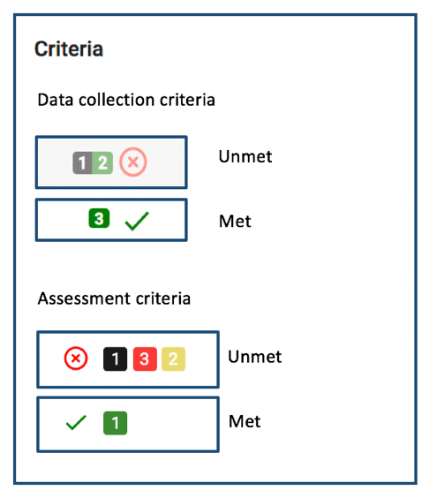

* **Caveats:** The format of the caveats column is identical across all three sections. Caveats are shown as colored circles with numbers indicating the total number of questionnaire responses that invoked a caveat of that particular color. There are three types of caveats:
  1. **Cautionary, or warning caveats:** these are marked as red, orange, and yellow circles with the severity or strength of the caveat corresponding to the color (red being highest). These give cautionary guidance based on an attribute of a fishery. For example, if the user responded that the species of interest is susceptible to barotrauma, this would invoke a red caveat against size limits as a management measure, since the fishing-induced mortality of the released (under- or over-sized) fish would render size limits ineffective.
  2. **Positive attributes:** A green colored caveat provides reasoning for why the option might be well-suited for the fishery on the basis on a of a user response in the questionnaire.
  3. **Static caveats:** Turquoise colored caveats are static caveats that need to be considered for an option, regardless of the fishery or the questionnaire responses. A static caveat is independent of specific fishery circumstances and as such are always present. These include key assessment assumptions, for example, that the assessment option assumes that fishery selectivity has not changed over time, or that the assessment method cannot explicitly address uncertainty.

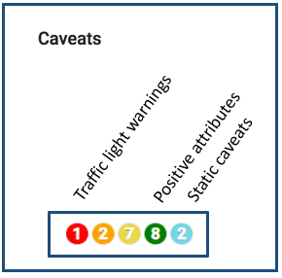

* **(Data) Category:** The Category column allows the user to view the options by categories. This column is different for each section. In the Data Collection Section, this column is titled “Data Category”, showing the four categories of the type of data that may be collected (see also “Data Collection Section Results” above). In the Assessment Section, this column is titled either “Input-Based Category” or “Output-Based Category”, reflecting two sorting options available for organizing the assessment option results. In the Management Measures Section, this column is simply titled “Category” and displays the categories of management measures.
* **Option:** This is the name of the option being considered.

### Full Option Details

Each row in the Results Table displays the option name with summarized results for each option. When users click on any option, a pop-up box appears, which provides full details of the option itself, together with the detail of the criteria and caveats invoked.

First, a description of the option is provided, together with relevant references, and contact information (if available or appropriate). For the Data Collection options, the types of data that may be collected using the option are summarized. For the Assessment section, where available, links to assessment packages are provided.

Next, the invoked criteria and caveats are summarized by (Figure 16)

* Criteria not met,
* Met criteria,
* Cautionary caveats,
* Positive attribute caveats, and
* Static caveats

Next to each, there are individual drop-down menus where the user can find the specific detail on each individual criterion and caveat, along with the question and response that invoked the criterion or caveat.

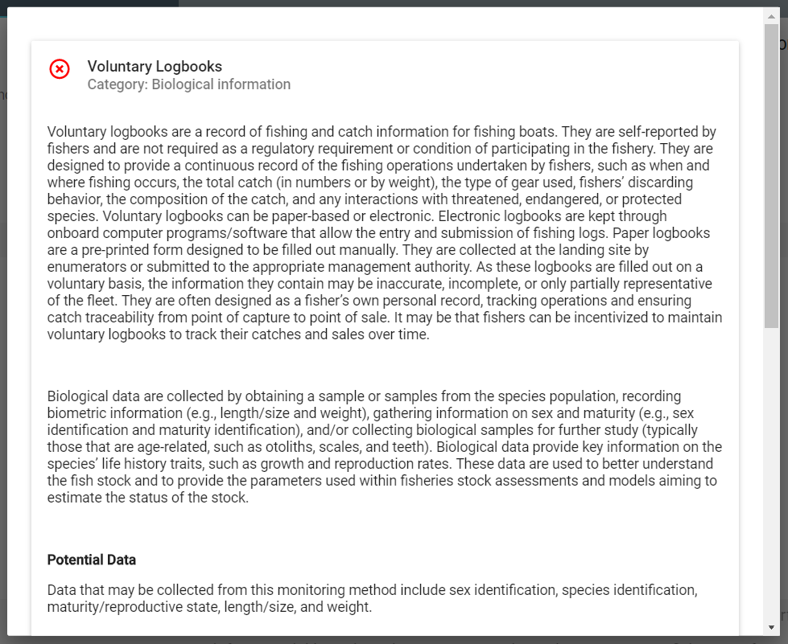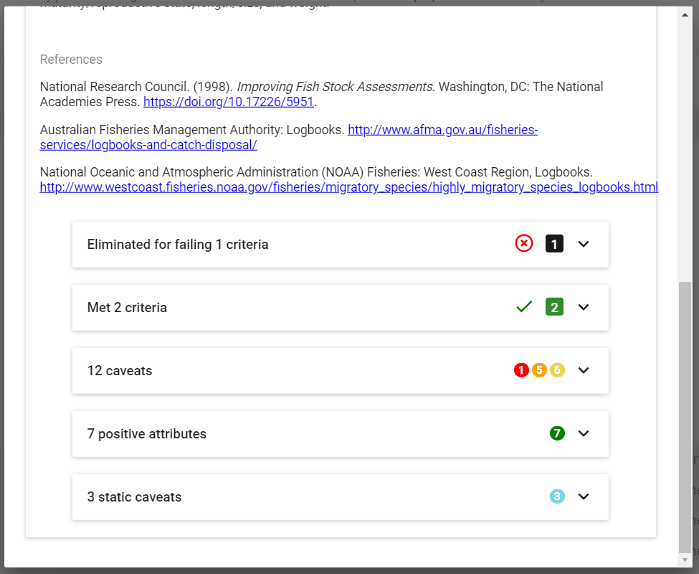

**Criteria drop-down box (Figures 18-19)**: Each criterion drop-down shows the relevant question with the user’s response shown (highlighted in black) relative to the minimum required level for that option (where green coloring starts on left) (Figure 18). The Assessment section assigns traffic light colors to levels above the minimum, indicating their relative uncertainty and thus the relative caution that should be taken (Figure 19).

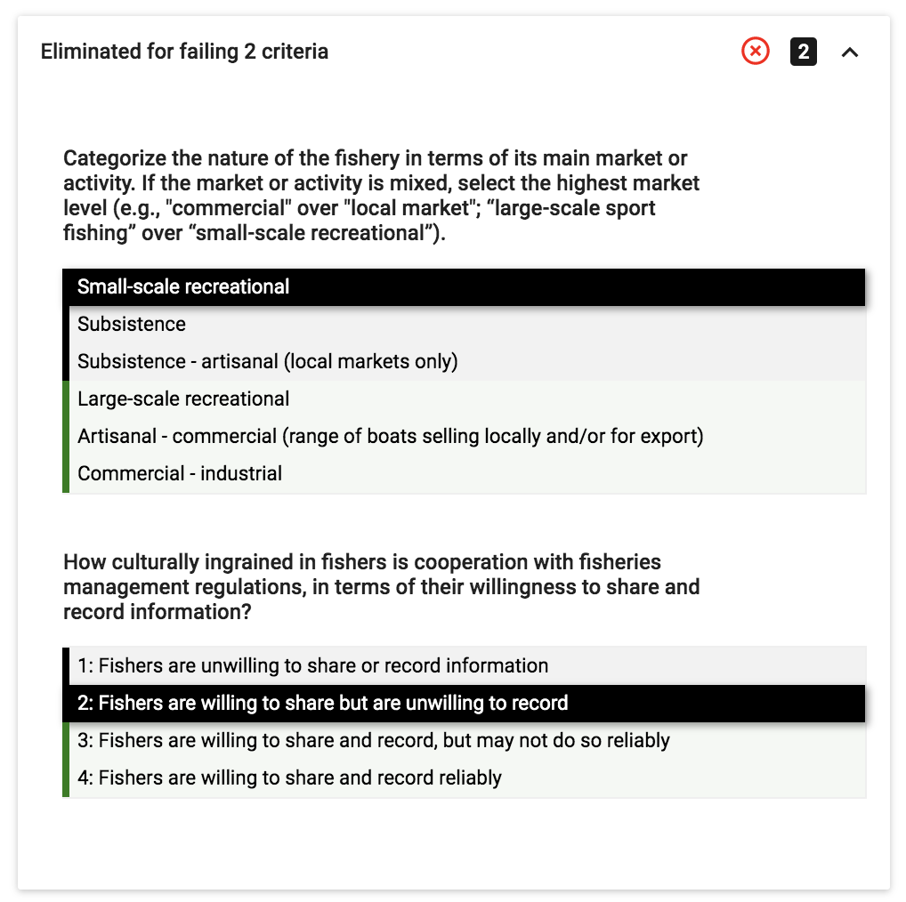

Figure 18: Example drop-down menu with details for an option in the Data Collection section that was eliminated for failing two criteria. The bold, black box and white text indicates the user answer to the question. The black answer options indicate those that result in elimination if selected. The green answer options indicate those that would have resulted in acceptance if selected.

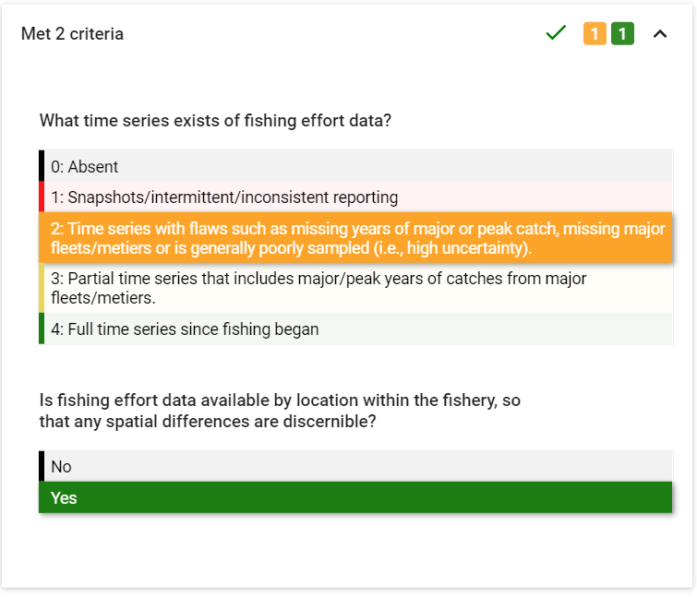

Figure 19: Example drop-down menu with details for an option in the Assessment section that has passed criteria, but indicating the user to take caution regarding the uncertainty in the fishing effort data. Red indicates high uncertainty in the data. Green indicates low uncertainty.

**Caveat Drop-Down Box (Figures 20-22)**: Each individual caveat box displays the FishPath question with the user’s answer in grey text, followed by caveat text related to the use of the option in the fishery in the context of that particular question response. The color of each box reflects the caveat color (see caveat descriptions above): cautionary caveats shaded yellow, orange or red; positive attributes shaded green; and static caveats shaded in turquoise.

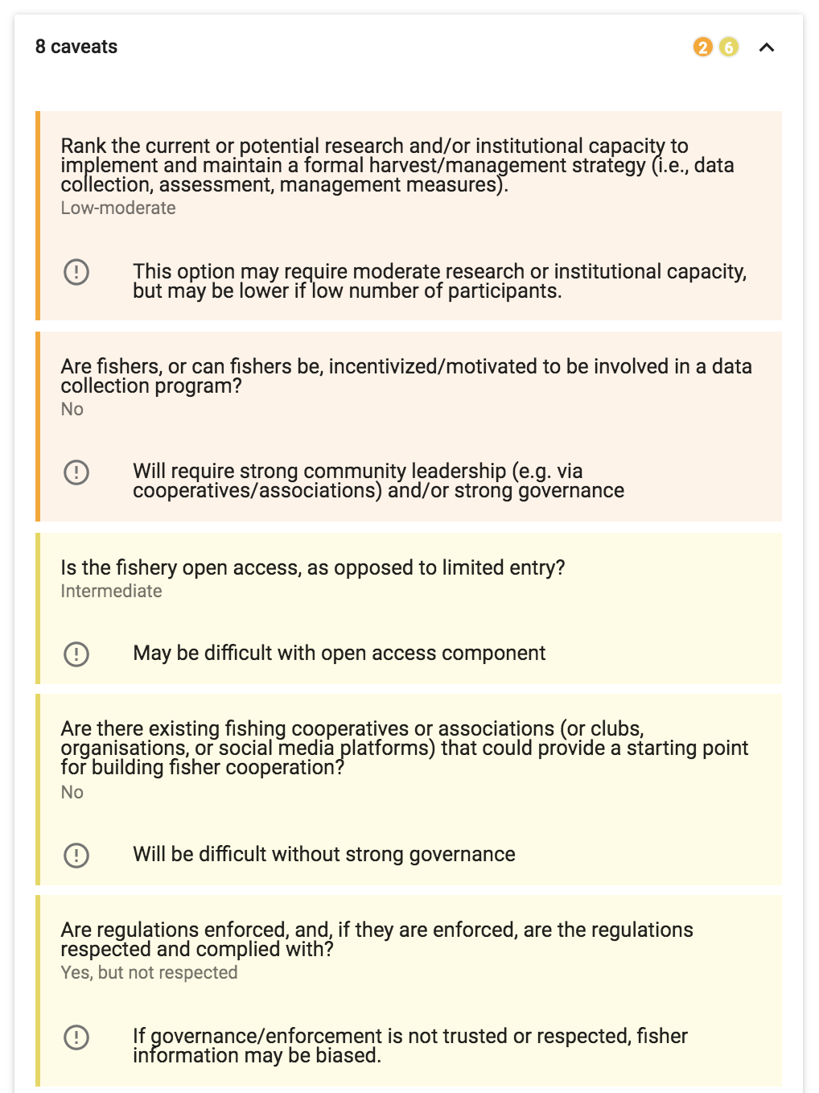

Figure 20: Example caveat drop-down menu with details for an option for which questionnaire responses invoked 8 cautionary caveats (2 orange, 6 yellow, as shown at the top right corner of the drop-down menu).

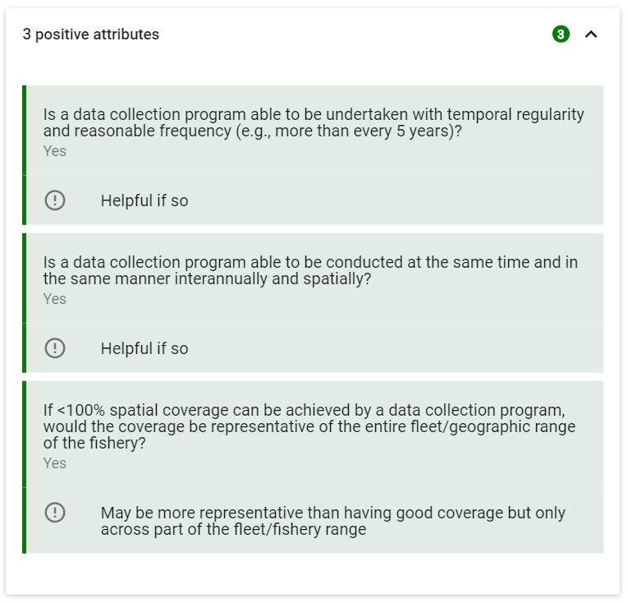

Figure 21: Example drop-down menu of positive attributes for an option for which questionnaire responses invoked 5 positive attributes (shown at the top right corner of the drop-down menu).

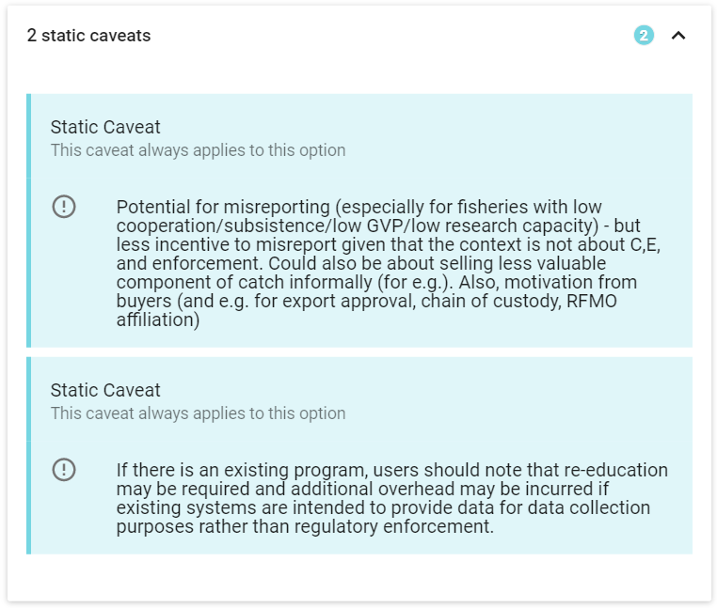

Figure 22: Example static caveat drop-down menu for an option with 3 static caveats (shown at the top right corner of the drop-down menu). Each individual static caveat box displays grey text to note “This caveat always applies to this option”, and a short explanation of the static caveat.

### More Information on Options within the 3 Results Sections

#### Data Collection Section Results

The Data Collection section of the FishPath tool includes a range of data collection options (from market surveys, to logbooks and observer programs). These data collection options are subdivided according to the broad category of data that may be collected, as these influence the viability of the data collection option. The four data categories in the FishPath tool are: 1) biological information; 2) data that yield a basic understanding of the fishery; 3) data that can inform temporal trend analyses (data time series), and 4) data that are of a sufficient quality to inform a model-based stock assessment.

#### Assessment Section Results

The Assessment section of the FishPath tool allows the user to understand which data-limited stock assessment methods are available and best suited to their fishery. In the FishPath tool, an assessment is defined as any analysis or performance indicator that gives useful information for management by direct or indirect measures of stock status. This could range from a “cause for concern” arising from expert judgement, qualitative risk assessments, values of empirical indicators relative to pre-defined trigger levels, multiple indicator frameworks, to life history analyses that provide estimates of fishing mortality, F, or fishing mortality at maximum sustainable yield FMSY, catch-only models, size or length based approaches, to population dynamics model-fitting approaches that estimate biomass.

#### Management Measure Section Results

A management measure is the form of control used to manage the fishing mortality. Once the desired management measures have been identified (for example, size limits, or catch adjustments in response to quantitative assessment outcomes), they are adjusted via “decision rules”, or “harvest control rules”. These specify the strength and nature of the pre-agreed management action to be taken given the status of the fishery, as determined by the assessment. Management measures can take many forms including spatial, temporal, effort, catch, and gear related restrictions. The FishPath tool does not have any minimum criteria listed for management measures, but instead uses cautionary caveats. Multiple management measures can and should be used together. The FishPath tool results do not prescribe or give guidance on the specific form of the harvest rule, nor the strength of adjustment in response to assessment outcomes. However, the FishPath tool does direct users to resources and tools that can support in this process, located within the description of each option.

## Show Hidden Options and Sort Options

The “Show Hidden Options” Toggle (Figure 23) allows users to display or not display those options that have been “hidden” (greyed out) in the results table. When shown, “hidden” options will appear in grey.

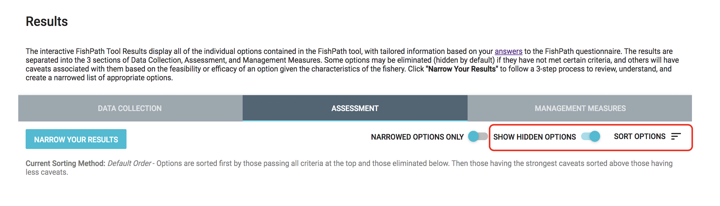

Figure 23: Results page with the “Show Hidden Options” Toggle and “Sort Options” in a red circle.

The “Sort Options” functionality allows the user to arrange and view the options in different ways. This does not affect the results or shortlisting of options; it is merely a means to organize and display the results.

After clicking “Sort Options”, a pop-up box (Figure 24) appears with the ability to sort the options by:

* In the Assessment section only, there is an additional option to sort by two categories: “Output-Based Category” (i.e., according to the general type of output generated by the assessment method or option); or “Input-Based Category” (i.e., according to the main form of input required by the assessment or option).
* **Default Order:** The default sort is to list all options that did not meet minimum criteria at the bottom (automatically greyed out as hidden options), with the options for which the highest number of cautionary caveats were invoked at the top for review.
* **Customized Sort Order:** This maintains the current sort order but allows users to return to the results table and “drag and drop” options into the preferred order.
* **Sort by option name:** Sorts options alphabetically by option name.
* **Sort by category:** Sorts options alphabetically by category name. For the Assessment section, users first select the Category Display that they want to display and sort by.

Clicking a Sort option automatically sorts the options on the screen. After making selections on the Sort window, users can click outside of the pop-up onto the results table to return to the results. The current sort selected is shown at the top of the results table at “Current Sorting Method” (Figure 23).

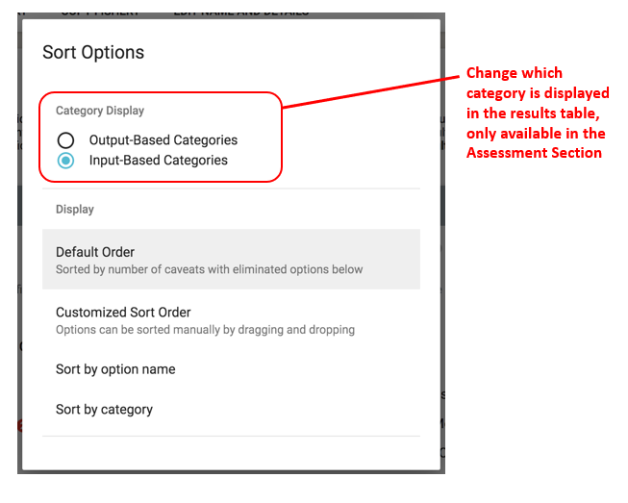

Figure 24: Sort Options pop-up box.

## Bookmarked Questions and Influential Answers

If the user scrolls to the bottom of the results screen (below results table), they are provided with a summary list of the questions bookmarked by the user, together with a list of “Influential Answers”, and, finally, a “See All Answers” link.

### Bookmarked Questions

All questions that were “bookmarked” during the questionnaire will be listed here (Figure 25). Users can select each question to get a detailed list of all caveats invoked or criteria not met based on the response. Users can also select each question to change the answer, add notes, or remove bookmark. It is highly recommended to review these questions and invoked caveats so that users can update their response or provide more detailed notes on the response, based on seeing how the response impacts results.

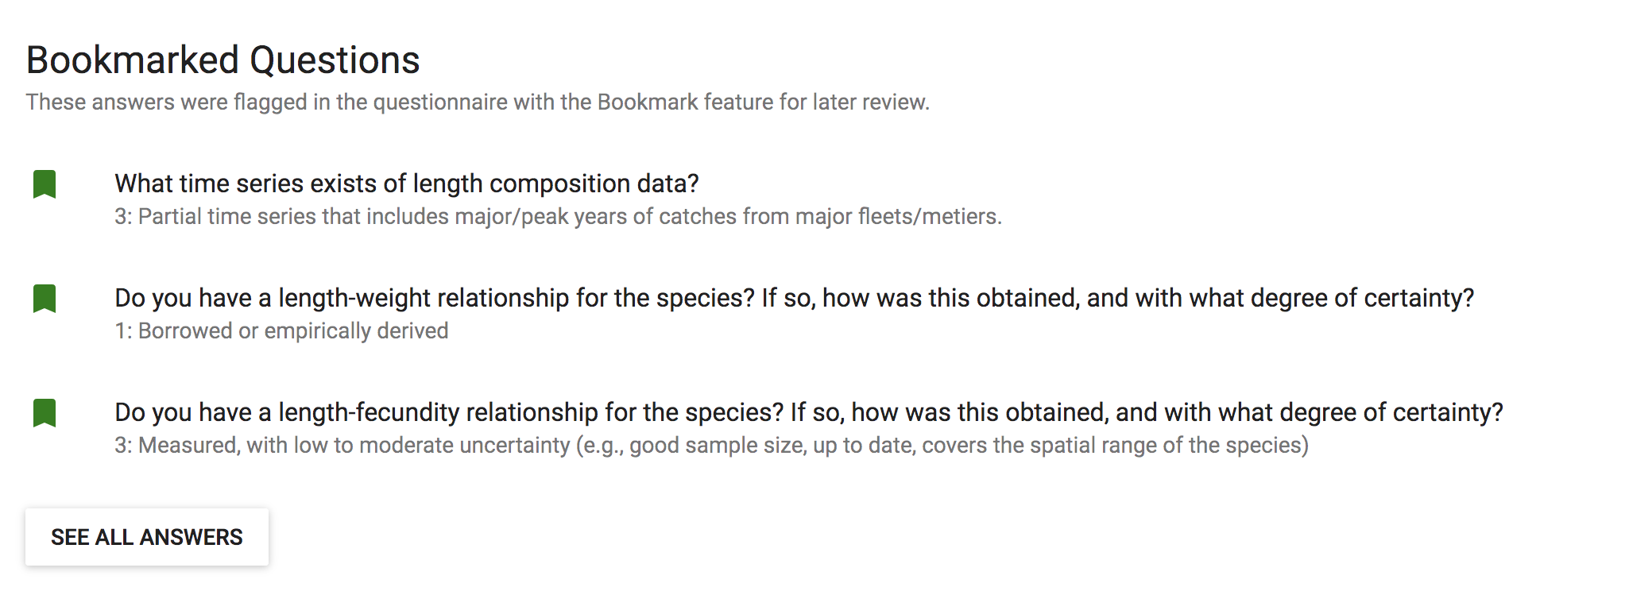

Figure 25: List of bookmarked questions.

### Influential Answers

The “Influential Answers” list is a summary of the questions and user responses that invoked the most eliminating criteria (by number), together with the number of caveats and criteria invoked, by assigned traffic light color (Figure 26). The caveats invoked by the question are displayed (color strength and number) to its left.

It is recommended to review this list prior to entering the results narrowing process (described below), to better understand some of the key challenges facing the fishery. Users can select any question on this list to change an answer, add notes to the question, and see a list of all impacted options and their associated caveats (Figure 27).

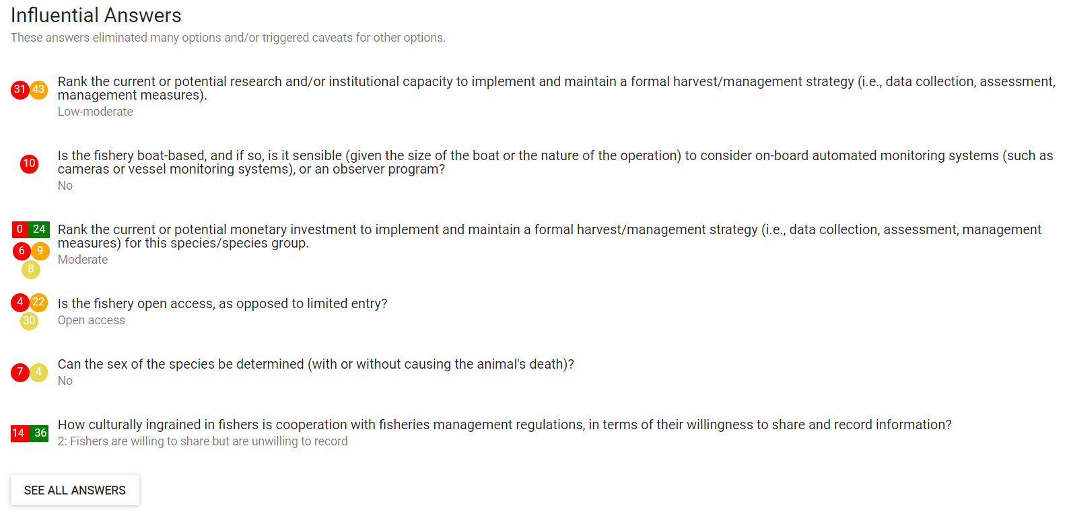

Figure 26: List of influential answers.

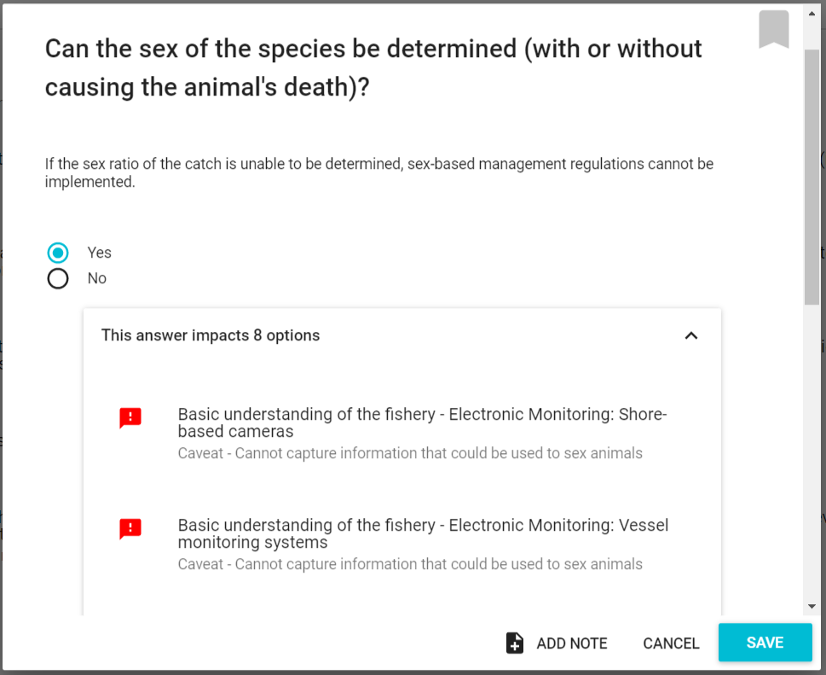

Figure 27: Impacted options for a question.

At the bottom of these lists, there is a link to “See All Answers” (as well as at the top of the results screen under “Answers”). These links take users to a full list of answers from each section, showing all information, including the number of caveats invoked, and any bookmarked questions. This is a good resource for users wanting to review the questionnaire responses for a fishery. Answers may also be changed and notes added, which update after clicking “Save”.

## Results Narrowing Process

Typically, the FishPath questionnaire process results in a long list of potential options that are presented to the user. The challenge is to then refine this to a workable shortlist of options that can be reviewed in further detail, and around which a draft harvest strategy can be developed. This can be a daunting task, given the number of options, and the large amount of detail around the criteria and caveats invoked against each. As such, the Results Review provides guidance as to how to undertake the task of narrowing the list of viable harvest strategy components.

The Results Narrowing process prompts the user through a series of steps to further refine and narrow the options for their fishery, and to consider detail about the application of each option in the fishery. The goal is to finish with a short list of defensible, appropriate and documented options for the fishery.

First, the user accesses the Results Narrowing process by selecting the “Review Top Options” button located above the Results Table in the Results Screen. (See Figure 13)

After clicking on “Review Top Options”, the user is directed to a step-wise results review process (Figure 28). Each step of the results review process contains an “Instructions” box with clear steps, as well as the ability to access different steps of the results review process through “Back”, “Exit Review” and “Next Step” (Figure 28). Across the top of the page, the user views steps in the process:

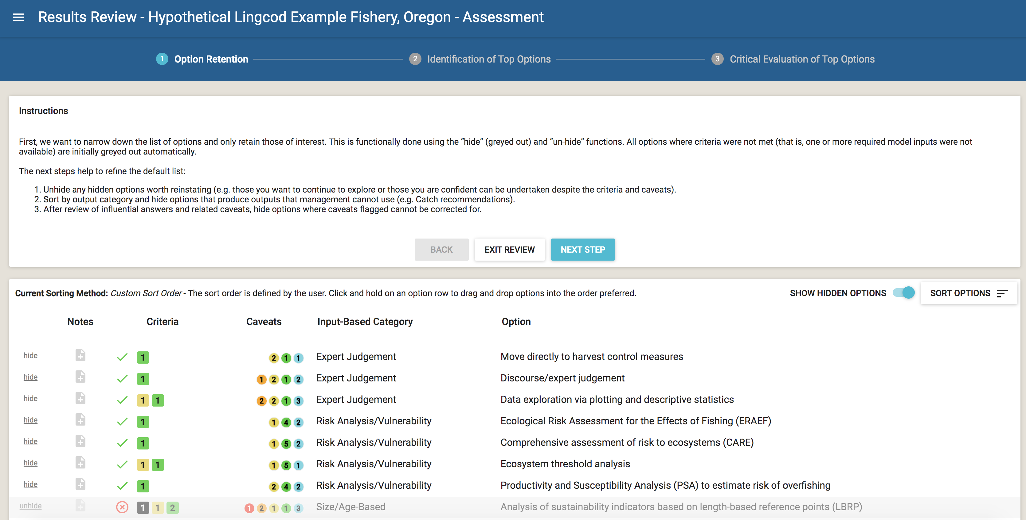

Figure 28: Overview of the FishPath Tool results screen and results review process.

The narrowing process (done as a group exercise or by independent users), consists of the following major steps:

1. **Option Retention (Figure 29):** The goal of the first step is to hide all options that are clearly not viable for the fishery due to failure to meet minimum criteria, logistical, political, or other major reasons. Users should carefully review the list to hide these options, as well as un-hide options that they want to reinstate. Specific instructions are included on the screen in this step of the process, including questions to consider as narrowing the list.



Figure 29: Step 1, Option Retention, in the results review process.

1. **Identification of Top Options (Figure 30):** In this step, users review each remaining option to identify a short list of starred options that will be seriously considered and explored in more detail. Users should familiarize themselves with the sorting feature and the influential answer list (see above) to facilitate this process. When comparing options, users should compare the number of cautionary caveats and criteria, their relative strength, and the ratio of cautionary caveats to positive attribute caveats. Specific instructions are included on the screen in this step of the process.

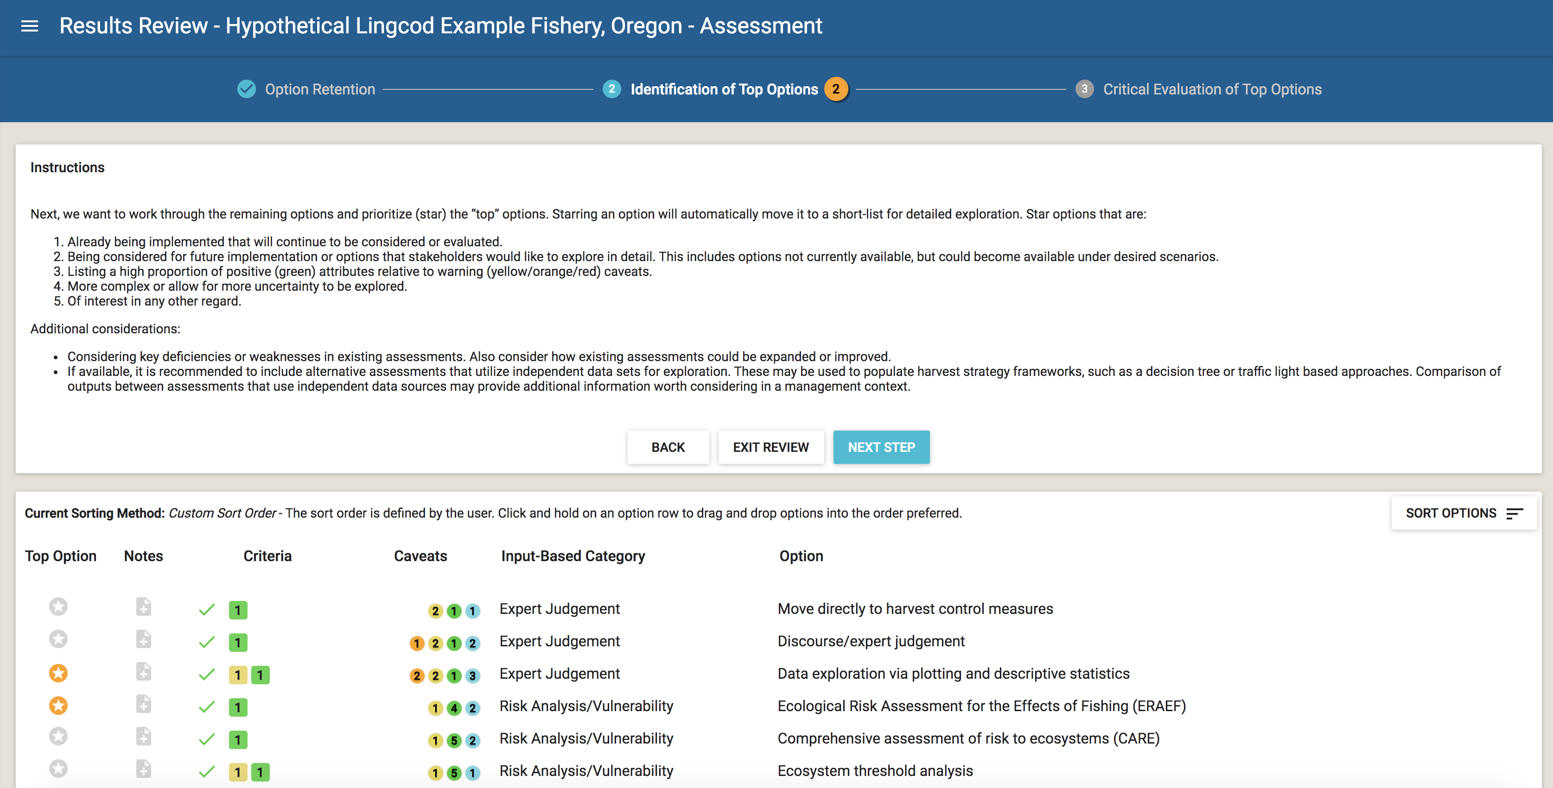

Figure 30: Step 2, Identification of Top Options, in the results review process.

1. **Critical Evaluation of Top Options (Figure 31):** In the final step, users can more critically evaluate the top options by considering each criterion and caveat in complete detail, and, potentially, ranking the options in order of potential. To facilitate this process, users can export a report that lists the top options and all of their details.

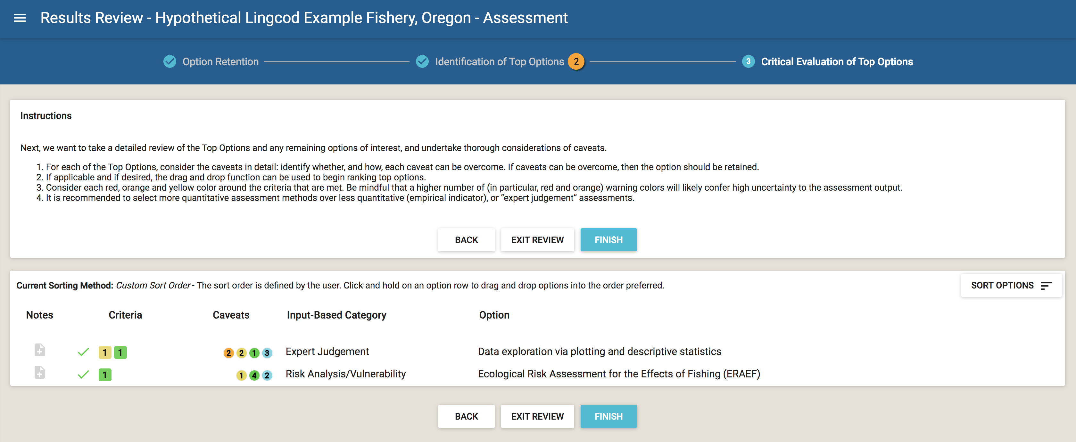

Figure 31: Step 3, Critical Evaluation of Top Options, in the results review process.

# (APPENDIX) Appendix

# FishPath Tool Frequently Asked Questions

**How do I submit feedback about content or user experience?**

FishPath benefits from the expertise and feedback of the global community of FishPath tool users. Users are encouraged to submit feedback about the FishPath tool, ultimately helping to improve the tool. There are two ways to submit feedback:

1. The “Submit Feedback” button on FishPath Tool Dashboard. The user is prompted to categorize their feedback as “Content Related” or “Software Issue”.
2. Email [support@fishpath.org](mailto:support@fishpath.org)

**How is my feedback addressed and incorporated?**

The FishPath Tool undergoes periodic updates to ensure that the tool reflects the latest fisheries science and management information. User-submitted feedback and suggestions, as well as information from periodic reviews of the tool, are collated and synthesized by the FishPath Core Team and addressed and incorporated.

**How often is the FishPath tool updated?**

Every 6 months.

**How will I know about updates to the FishPath tool?**

All FishPath users will receive an email every 6 months when updates are published. Common changes that users may expect are the addition of new options and questions. When they revisit the FishPath tool, they may need to answer new questions to see results and they may have new options in the results.

**Are answers to new questions also updated in “copied fisheries”?**

Once a fishery is copied, changes in the original or copied fishery will have no effect on the other.

# FishPath Tool Terms of Service

**Last revised on October 23, 2018**

The Nature Conservancy (“TNC,” “we,” “us,” or “our”) are pleased to provide FishPath and related software, data, websites, instructions, and services (“FishPath”) to you. If you are using FishPath on behalf of a business (such as your employer), that business accepts these terms of service (“Terms”) by your use. In that case, the words “You” and “Your” in these Terms refer to both you and that business.

The Terms govern Your access to and use of FishPath, so please carefully read them and Our Privacy Policy before using FishPath. By registering on the FishPath websites and using FishPath, You agree to be bound by these Terms and by our Privacy Policy. If You don’t agree with these Terms and our Privacy Policy, You cannot use FishPath or FishPath data in any way or at any time.

#### FishPath Data: Your Rights and Your Privacy

We developed FishPath as a user-friendly application to help users diagnose the challenges in their fishery and select appropriate options for data collection, stock assessment, and management measures. FishPath allows You to use Your fishery information (Your “Submission”). Your Submission to FishPath is voluntary. If You submit information to FishPath, these Terms do grant us the right to see and use Your Submission to improve the functionality of the tool as appropriate. We may copy and share an anonymized aggregation of information from submissions, potentially including Your Submission, with the public. However, we will not share Your submission nor Your information in any non aggregated format.

Please refer to our [Privacy Policy](https://www.nature.org/en-us/about-us/who-we-are/accountability/privacy-policy/) for a description of how we collect, use and disclose FishPath information, including Your Submission. We have the right to withdraw or change FishPath. As we describe below, we will not be liable to You if for any reason all or any part of FishPath is unavailable at any time or for any length of time.

#### Your Responsibilities

Only make a Submission if You have all necessary rights to share the information with us, including but not limited to use with FishPath. You are solely responsible for your conduct and Your Submission while using FishPath. It is Your responsibility to ensure that You have the rights or permission needed to comply with these Terms.

Respect the law. Do not use FishPath for any fraudulent or unlawful purpose including violations of statutory, regulatory or contractual law. Respect copyright, privacy, trade secret, data protection, fish & wildlife and all other laws. Do not attempt to impersonate any other individual on FishPath; if You identify yourself, You must always use Your true identity.

Without our express written consent, You may not use, display, mirror, or frame FishPath, any element within FishPath, or any proprietary elements belonging to us (including but not limited to our logos and marks). In addition to adhering to all applicable laws and regulations, You may NOT do any of the following:

* resell FishPath or data from FishPath, or any portion thereof;
* access or search the FishPath data by using any engine, software, tool, agent, device or mechanism (including spiders, robots, crawlers, data mining tools or the like) other than the software and/or search agents that We provide or authorize;
* probe, scan, tamper with, or test the vulnerability of FishPath or any of our systems or networks;
* avoid, breach, deactivate, impair, or circumvent any security or authentication measures, including those that protect FishPath and its data;
* attempt to decipher, decompile, disassemble or reverse engineer any of the software used to provide FishPath;
* interfere with, or attempt to interfere with, the access of any user, host or network, including, without limitation, by sending a virus, overloading, or flooding FishPath;
* encourage or enable anyone else to do any of the foregoing.

We have the right to investigate violations of these Terms or conduct that affect FishPath or our systems or networks. We may also consult and cooperate with law enforcement authorities to prosecute users who violate the law.

#### Rights You Grant in Your Information

By making Your Submission, You grant us a non-exclusive, transferable, sublicensable, worldwide, perpetual, royalty-free license to use, copy, modify, create derivative works based upon, distribute, publicly display, publicly perform and distribute Your Submission. We will not, however, share or distribute specific notes You submit for Your fishery.

#### Rights That We Grant You

Subject to Your compliance with these Terms, we grant You a limited, non-exclusive, non-transferable, non-sublicensable, worldwide, royalty-free license to use the FishPath software, instructions, and websites and to view, copy, display, and create derivative works from the FishPath output that we make available from the FishPath site for Your management of Your fishery.

You may not: (i) copy, modify or create derivative works based on the FishPath software; (ii) distribute, transfer, sublicense, lease, or rent the FishPath software to any third party; or (iii) reverse engineer, decompile or disassemble the FishPath software.

Using FishPath or uploading Data does not give You ownership of any intellectual property rights in FishPath (other than your own Submission). We and our licensors exclusively own all right, title and interest in and to FishPath, including all associated intellectual property rights. You acknowledge that copyright, trademark, and other laws of the United States and foreign countries protect FishPath. You agree not to remove, alter or obscure any copyright, trademark, service mark or other proprietary rights notices incorporated in or accompanying FishPath.

These Terms do not grant You the right to use any of our branding or logos or names. You must not use our names or logos or branding without our written permission.

#### Modifying our Terms of Service

We may update these Terms from time to time, in our sole discretion. We may notify You of such updates by any reasonable means, such as by posting the revised Terms on the FishPath website. Please look at the “LAST UPDATED” legend above to see when these Terms were last revised. Your use of FishPath after the posting of any revised Terms means that You accept and agree to be bound by the revised Terms. If You don’t agree to be bound by the revised Terms, then You may not use FishPath anymore. You can stop using FishPath at any time. We may also stop providing FishPath or add or create new limits to FishPath at any time.

#### Disclaimers, Limited Liability and Indemnity

As we describe in more detail below, FishPath and its data are a general information resource and are provided solely “AS IS” and “AS AVAILABLE” without warranty of any kind. You should not construe publication of FishPath data as a warranty or guarantee of the quality or availability of any goods or services or technical support.

#### DISCLAIMERS AND LIMITATION OF LIABILITY

ALL CONTENT ON FISHPATH IS PROVIDED “AS IS” AND “AS AVAILABLE” WITHOUT WARRANTY OF ANY KIND, EITHER EXPRESS OR IMPLIED. WITHOUT LIMITING THE FOREGOING, WE EXPLICITLY DISCLAIM ANY AND ALL WARRANTIES OF MERCHANTABILITY, FITNESS FOR A PARTICULAR PURPOSE, QUIET ENJOYMENT, OR NON-INFRINGEMENT, AND ANY AND ALL WARRANTIES ARISING OUT OF COURSE OF DEALING OR USAGE OF TRADE. TNC MAKES NO WARRANTY AS TO THE QUALITY, ACCURACY, COMPLETENESS, TIMELINESS, OR RELIABILITY OF FISHPATH OR ANY FISHPATH CONTENT. YOUR USE OF FISHPATH IS AT YOUR SOLE RISK.

TNC MAKES NO REPRESENTATIONS OR WARRANTIES THAT YOUR USE OF FISHPATH WILL MEET YOUR NEEDS OR BE UNINTERRUPTED, SECURE, OR ERROR FREE. USERS ARE RESPONSIBLE FOR TAKING ALL NECESSARY PRECAUTIONS TO ENSURE THAT ANY CONTENT YOU MAY OBTAIN FROM THE SERVICES IS FREE OF VIRUSES OR OTHER HARMFUL CODE.

TO THE MAXIMUM EXTENT PERMITTED BY LAW, WE SHALL NOT BE LIABLE FOR CREATING, PRODUCING, MAINTAINING, OPERATING, OR PROVIDING FISHPATH OR FISHPATH CONTENT, UNDER ANY THEORY BASED IN CONTRACT, WARRANTY, TORT (INCLUDING NEGLIGENCE), PRODUCT LIABILITY, STRICT LIABILITY, OR OTHER LEGAL THEORY. THIS LIMITATION ON LIABILITY INCLUDES ANY AND ALL INDIRECT, INCIDENTAL, SPECIAL, EXEMPLARY OR CONSEQUENTIAL DAMAGES, INCLUDING LOST PROFITS, LOSS OF DATA OR GOODWILL, SERVICE INTERRUPTION, COMPUTER DAMAGE OR SYSTEM FAILURE OR THE COST OF SUBSTITUTE SERVICES ARISING OUT OF OR IN CONNECTION WITH THESE TERMS OR FROM THE USE OF OR INABILITY TO USE FISHPATH, EVEN IF WE HAVE BEEN ADVISED OF THE POSSIBILITY OF SUCH DAMAGES.

THE ABOVE EXCLUSIONS AND LIMITATIONS OF DAMAGES ARE FUNDAMENTAL ELEMENTS OF THE BASIS OF THE BARGAIN BETWEEN YOU AND US.

#### Indemnity

You agree to release, indemnify, defend and hold harmless TNC, our subsidiaries and affiliates, and our and their respective officers, directors, agents, partners and employees, from and against any claims, disputes, demands, liabilities, damages, losses, and costs and expenses, including, without limitation, reasonable legal and accounting fees arising out of or in any way connected with (i) Your access to or use of FishPath, (ii) Your Submission, or (iii) Your violation of these Terms.

#### Termination

We may terminate Your access to and use of FishPath, at our sole discretion, at any time and without notice to You. Upon any termination, discontinuation or cancellation of FishPath, all provisions of these Terms that by their nature should survive will survive. This includes, for example ownership provisions, warranty disclaimers, and limitations of liability.

#### General Terms

These Terms are the entire and exclusive agreement between You and us regarding FishPath, and they supersede any prior agreements between You and us regarding FishPath.

These terms do not create any third party beneficiary rights. You may not assign or transfer these Terms, by operation of law or otherwise, without our prior written consent. Subject to the foregoing, these Terms will bind your successors and permitted assigns. We may freely assign or transfer these Terms without restriction.

If You do not comply with these Terms, and we do not take action right away, this does not mean that we are giving up any rights that we may have to take action in the future or seek all available remedies.

If it turns out that a particular provision of these Terms is not fully valid or enforceable, that provision will be enforced to the maximum extent permissible, and this will not affect any other Terms.

All claims arising out of this Agreement or relating to FishPath will be governed by the laws of the State of California, excluding the application of its conflicts of law rules. Any legal action or proceeding arising out of this Agreement or relating to these Services shall be brought exclusively in a state or federal court in or for San Francisco, California. You agree that any and all disputes, claims and causes of action arising out of, or connected with these Terms or Your Submission shall be resolved individually, without resort to any form of class action.

# Glossary

Note: The [FAO Term Portal - Fisheries](http://www.fao.org/fishery/glossary/en) has some of the definitions in multiple languages.

### Absolute Abundance

The total number of a kind of ﬁsh in a population; this is rarely known, and usually estimated from the relative abundance.

Source: [Blackhart, K., Stanton, D. G., & Shimada, A. M. (2006). *NOAA fisheries glossary.* United States Department of Commerce, National Oceanic and Atmospheric Administration.](https://repository.library.noaa.gov/view/noaa/12856)

### B0 (Virgin Biomass)

“B0”, or virgin biomass, refers to the average biomass of a stock that has yet not been fished. It is generally calculated as the long-term average biomass value expected in the absence of fishing mortality. In production models, B0 is also known as carrying capacity. It is often used as a reference value to assist the relative health of a stock, monitoring changes in the ratio between current and virgin biomass (B/B0).

Source: Restrepo V. (1999): Annotated Glossary of Terms in Executive Summary Reports of the International Commission for the Conservation of Atlantic Tunas’ Standing Committee on Research and Statistics (SCRS), *ICCAT*.

via [FAO Term Portal - Fisheries](http://www.fao.org/fishery/glossary/en)

### Bias

An effect which deprives a statistical result of representativeness by systematically distorting it, as distinct from a random error which may distort on any one occasion but balances out on the average.

Source: [OECD Glossary](https://stats.oecd.org/glossary/detail.asp?ID=3605)

### Biological Overfishing

Catching such a high proportion of one or all age classes in a fishery as to reduce yields and drive stock biomass, and spawning potential below safe levels. Can involve both growth overfishing and recruitment overfishing. With reference to a surplus production model, biological overfishing occurs when fishing levels are higher that those required for extracting the maximum sustainable yield (MSY) of a resource.

Source: Garcia, S.M. (Comp.). 2009. Glossary. In Cochrane, K. and S.M. Garcia. (Eds). *A fishery manager’s guidebook*. FAO and Wiley-Blackwell:473-505.

via [FAO Term Portal - Fisheries](http://www.fao.org/fishery/glossary/en)

### Boom and Bust Population Cycle

Species that follow boom-and-bust cycles display high volatility in their population dynamics. This means that their availability is sudden, extreme, and unpredictable.

Source: FishPath Team

### Bycatch

Species that follow boom-and-bust cycles display high volatility in their population dynamics. This means that their availability is sudden, extreme, and unpredictable.

Source: Modified from FAO (1998): Guidelines for the routine collection of capture fishery data

via [FAO Term Portal - Fisheries](http://www.fao.org/fishery/glossary/en)

### Carrying Capacity

The maximum population of a species that a specific ecosystem can support indefinitely without deterioration of the character and quality of the resource. It represents the point of balance between reproduction potential and environmental constraints.

Source: Scialabba N. (ed.), 1998. *Integrated Coastal Area Management and Agriculture, Forestry and Fisheries*. FAO Guidelines, 256p.

via [FAO Term Portal - Fisheries](http://www.fao.org/fishery/glossary/en)

### Catch-Per-Unit-Effort (CPUE)

Catch-per-unit-effort (CPUE) is the quantity of fish caught (in number or in weight) with one standard unit of fishing effort; e.g. number of fish taken per 1,000 hooks per day or weight of fish, in tons, taken per hour of trawling. CPUE is often considered an index of fish biomass (or abundance). CPUE is sometimes referred to as catch rate, and may be used as a measure of economic efficiency of fishing as well as an index of fish abundance.

Source: Modified from FAO (1998a): Guidelines for the routine collection of capture fishery data. *FAO Fisheries Technical Paper.* No. 382. Rome, FAO. 113p.

via [FAO Term Portal - Fisheries](http://www.fao.org/fishery/glossary/en)

### Decision Rule

See Harvest Control Rule (HCR)

### Determinate Growth

Determinate growth means that the species does not grow indefinitely. The species stops growing once reaching a final adult stage.

Source: FishPath Team

### Economic Overfishing

Occurs when a fishery is generating no economic rent, primarily because an excessive level of fishing effort is applied in the fishery and does not always imply biological overfishing.

Source: FAO Fisheries and Aquaculture Department, FAO, 2014.

via [FAO Term Portal - Fisheries](http://www.fao.org/fishery/glossary/en)

### Ecosystem Overfishing

Occurs when the historical species balance (composition and dominance) is significantly modified by fishing (e.g. with reductions of large, long-lived, demersal predators and increases of small, short-lived species at lower trophic levels).

Source: FAO Fisheries and Aquaculture Department, FAO, 2014.

via [FAO Term Portal - Fisheries](http://www.fao.org/fishery/glossary/en)

### Effort Creep

Effort creep refers to an increase in effort effectiveness owing to technological progress. These progressions increase the productivity of fishing power, therefore increasing the effective effort. For example, although the number of vessels may be regulated, an increasing number of hooks per vessel or increasing vessel fuel efficiency may demonstrate effort creep.

Source: Squires, Dale, et al. “Effort rights in fisheries management: general principles and case studies from around the world.” *Effort rights in fisheries management: General principles and case studies from around the world*. Food and Agriculture Organization of the United Nations, 2016.

### Equilibrium

In population ecology, equilibrium refers to a state of balance.

Source: FishPath Team

### Fecundity

Fecundity is the potential reproductive capacity of an organism or population expressed in the number of eggs (or offspring) produced during each reproductive cycle. Fecundity usually increases with age and size.

Source: [Blackhart, K., Stanton, D. G., & Shimada, A. M. (2006). *NOAA fisheries glossary.* United States Department of Commerce, National Oceanic and Atmospheric Administration.](https://repository.library.noaa.gov/view/noaa/12856)

### Fishery

A unit determined by an authority or other entity that is engaged in raising and/or harvesting fish. Typically, the unit is defined in terms of some or all of the following: people involved, species or type of fish, area of water or seabed, method of fishing, class of boats and purpose of the activities.

Source: Fletcher, W.J., Chesson, J. Fisher, M., Sainsbury K.J., Hundloe, T. Smith A.D.M., and B. Whitworth (2002): National ESD reporting framework for Australian fisheries: The “How To” guide for wild capture fisheries. FRDC Project 2000/145. Canberra, Australia

via [FAO Term Portal - Fisheries](http://www.fao.org/fishery/glossary/en)

### Fishery-Dependent Data

Data collected directly on a fish or fishery from commercial or sport fishermen and seafood dealers. Common methods include logbooks, trip tickets, port sampling, fishery observers, and phone surveys.

Source: [Blackhart, K., Stanton, D. G., & Shimada, A. M. (2006). *NOAA fisheries glossary.* United States Department of Commerce, National Oceanic and Atmospheric Administration.](https://repository.library.noaa.gov/view/noaa/12856)

### Fishery-Independent Data

Characteristic of information (e.g. stock abundance index) or an activity (e.g. research vessel survey) obtained or undertaken independently of the activity of the ﬁshing sector. Intended to avoid the biases inherent to ﬁshery-related data.

Source: [Blackhart, K., Stanton, D. G., & Shimada, A. M. (2006). *NOAA fisheries glossary.* United States Department of Commerce, National Oceanic and Atmospheric Administration.](https://repository.library.noaa.gov/view/noaa/12856)

### Fishery Effort

The amount of fishing gear of a specific type used on the fishing grounds over a given unit of time for example hours trawled per day, number of hooks set per day or number of hauls of a beach seine per day. When two or more kinds of gear are used, the respective efforts must be adjusted to some standard type before being added.

Source: FAO. 1997. *Fisheries management*. FAO Technical Guidelines for Responsible Fisheries No. 4. Rome, FAO. 82p.

via [FAO Term Portal - Fisheries](http://www.fao.org/fishery/glossary/en)

### Fishing Mortality (F)

The instantaneous rate of fish deaths due to fishing a component of the fish stock. F reference points may be applied to entire stocks or segments of the stocks.

Source: <https://www.fish.gov.au/about/glossary>

### Growth Overfishing

Occurs when too many small fish are being harvested too early, through excessive fishing effort and poor selectivity (e.g. too small mesh sizes) and the fish are not given enough time to grow to the size at which the maximum yield-per-recruit from the stock would be obtained. A reduction of fishing mortality on juveniles, or their outright protection, would lead to an increase in yield from the fishery. Growth overfishing, by itself, does not affect the ability of a fish population to replace itself.

Source: FAO Fisheries and Aquaculture Department, FAO, 2014.

via [FAO Term Portal - Fisheries](http://www.fao.org/fishery/glossary/en)

### Harvest Control Rule (HCR)

Also “decision rule”. A formally defined, usually quantitative rule, that is used to adjust a management measure in reponse to some known or inferred status of the fished stock. The strength of adjustment of the management measure is usually some function of a performance measure - that is, the proximity of a performance indicator to a target or limit reference point.

Source: FishPath Team

### Harvest Strategy

Also “management strategy”. A harvest (or management) strategy is a formal, pre-specified set of rules designed to achieve the management objectives for the fishery. Harvest strategies (HSs) are formal frameworks for managing exploitation of fisheries, usually applied to the target species (e.g. Sainsbury et al. 2000, Butterworth and Punt 2003). They comprise a fully-specified set of rules for making tactical management decisions including specifications for i) a monitoring (data collection) program, ii) the indicators to be calculated from monitoring data (usually via a stock assessment) and iii) the use of those indicators and their associated reference points in management decisions, through application of decision (or control) rules.

Sources: Butterworth, D.S., and Punt, A.E. 2003. The role of harvest control laws, risk and uncertainty and the precautionary approach in ecosystem-based management. *Responsible Fisheries in the Marine Ecosystem*: 311-319.

Sainsbury, K.J., Punt, A.E., and Smith, A.D.M. 2000. Design of operational management strategies for achieving fishery ecosystem objectives. *ICES Journal of Marine Science* 57: 731-741.

### Illegal, unregulated, and unreported (IUU) Fishing

Reference to broad activities classified as illegal, unreported and unregulated fishing are included in the IPOA-IUU as follows:

*Illegal fishing*:

-conducted by national or foreign vessels in waters under the jurisdiction of a State, without the permission of that State, or in contravention of its laws and regulations; -conducted by vessels flying the flag of States that are parties to a relevant regional fisheries management organisation but operate in contravention of the conservation and management measures adopted by that organisation and by which the States are bound, or relevant provisions of the applicable international law; or -in violation of national laws or international obligations, including those undertaken by cooperating States to a relevant regional fisheries management organization.

*Unreported fishing*:

-which have not been reported, or have been misreported, to the relevant national authority, in contravention of national laws and regulations; or -are undertaken in the area of competence of a relevant regional fisheries management organisation which have not been reported or have been misreported, in contravention of the reporting procedures of that organisation.

*Unregulated fishing*:

-in the area of application of a relevant regional fisheries management organization that are conducted by vessels without nationality, or by those flying the flag of a State not party to that organization, or by a fishing entity, in a manner that is not consistent with or contravenes the conservation and management measures of that organization; or -in areas or for fish stocks in relation to which there are no applicable conservation or management measures and where such fishing activities are conducted in a manner inconsistent with State responsibilities for the conservation of living marine resources under international law.

Source: <http://www.fao.org/iuu-fishing/background/what-is-iuu-fishing/en/>

### Indicators

A variable, pointer, or index. Its fluctuation reveals the variations in key elements of a system. The position and trend of the indicator in relation to reference points or values indicate the present state and dynamics of the system. Indicators provide a bridge between objectives and action.

Source: FAO (1999): Indicators for sustainable development of marine capture fisheries. *FAO Technical Guidelines for Responsible Fisheries*, 8: 68 p. Rome, FAO

via [FAO Term Portal - Fisheries](http://www.fao.org/fishery/glossary/en)

### Intrinsic growth rate (r)

A value that quantifies how much a population can grow between successive time periods. The intrinsic growth rate is often estimated with production models and plays an important role in evaluating the sustainability of different harvest levels and the capacity to recover after depletion.

Source: Restrepo V. (1999): Annotated Glossary of Terms in Executive Summary Reports of the International Commission for the Conservation of Atlantic Tunas Standing Committee on Research and Statistics (SCRS). *ICCAT*.

via [FAO Term Portal - Fisheries](http://www.fao.org/fishery/glossary/en)

### Latent effort

Fishing capacity that is authorised for use but not currently being used. Depending on how a fishery is managed, latency might appear in effort (for example, unused vessel statutory fishing rights [SFRs], gear SFRs, quota SFRs, permits or nights fishing) or in quota (for example, where total allowable catches [TACs] are not fully caught in a quota-managed fishery). It can be an indicator of fishers’ views about the profitability of a fishery, with high levels of latency suggesting that low expected profits in the fishery do not justify fishing.

Source: <https://www.fish.gov.au/about/glossary>

### Length-weight relationship

A mathematical formula for calculating the weight of a ﬁ sh in terms of its length. When only one is known, the formula can determine the other

Source: [Blackhart, K., Stanton, D. G., & Shimada, A. M. (2006). *NOAA fisheries glossary.* United States Department of Commerce, National Oceanic and Atmospheric Administration.](https://repository.library.noaa.gov/view/noaa/12856)

### Limit reference point

Indicates the limit beyond which the state of a fishery and / or a resource is not considered desirable. Fishery development should be stopped before reaching it. If a LRP is inadvertently reached, management action should severely curtail or stop fishery development, as appropriate, and corrective action should be taken.

Source: Garcia S.M. (1996)The precautionary approach to fisheries and its implications for fishery research, technology and management: An updated review. *FAO Fisheries Technical Paper*, 350.2: 1-76

via [FAO Term Portal - Fisheries](http://www.fao.org/fishery/glossary/en)

### Management Strategy

See Harvest Strategy

### Maturity ogive

The curve resulting from the proportion of mature fish at a given size or length.

Source: FishPath Team

### Maximum sustainable yield (MSY)

The highest theoretical equilibrium yield that can be continuously taken (on average) from a stock under existing (average) environmental conditions without affecting significantly the reproduction process.

Source: FAO Fisheries and Aquaculture Department, FAO, 2014.

via [FAO Term Portal - Fisheries](http://www.fao.org/fishery/glossary/en)

### Multispecies fishery

A multispecies fishery is a fishery in which more than one species is caught at the same time. Because of the imperfect selectivity of most fi shing gears, most fisheries are “multispecies.” The term is often used to refer to fisheries where more than one species is intentially sought and retained.

Source: [Blackhart, K., Stanton, D. G., & Shimada, A. M. (2006). *NOAA fisheries glossary.* United States Department of Commerce, National Oceanic and Atmospheric Administration.](https://repository.library.noaa.gov/view/noaa/12856)

### Natural mortality (M)

Deaths of fish from all causes except fishing (e.g. ageing, predation , cannibalism, disease and perhaps increasingly pollution). It is often expressed as a rate that indicates the percentage of fish dying in a year; for example a natural mortality rate of 0.2 implies that approximately 20% of the population will die in a year from causes other than fishing.

Source: FAO Fisheries and Aquaculture Department, FAO, 2014.

via [FAO Term Portal - Fisheries](http://www.fao.org/fishery/glossary/en)

### No-take reserve

Areas where extractive activities are prohibited

Sala, E., and Giakoumi, S. 2017. No-take marine reserves are the most effective protected areas in the ocean. – ICES Journal of Marine Science, 75: 1166–1168.

### Nursery grounds

Nursery grounds refers to the part of a fish’s or animal’s habitat where the young develop and grow.

Source: [Blackhart, K., Stanton, D. G., & Shimada, A. M. (2006). *NOAA fisheries glossary.* United States Department of Commerce, National Oceanic and Atmospheric Administration.](https://repository.library.noaa.gov/view/noaa/12856)

### Open Access

Any fishery that does not limit effort or inclusion in the fishery. A fishery without permits or one with unlimited permits are both examples of an open access fishery.

Source: FishPath Team

### Overfished

A stock is considered overfished when exploited beyond an explicit limit beyond which its abundance is considered “too low” to ensure safe reproduction. In many fisheries fora the term is used when biomass has been estimated to be below a limit biological reference point that is used as the signpost defining an “overfished condition”.

Source: Mace, P.M. 1998. The status of ICCAT species relative to optimum yield and overfishing criteria recently proposed in the United States, also with consideration of the precautionary approach. *ICCAT* SCRS/97/074.

via [FAO Term Portal - Fisheries](http://www.fao.org/fishery/glossary/en)

### Overfishing

A generic term used to refer to the state of a stock subject to a level of fishing effort or fishing mortality such that a reduction of effort would, in the medium term, lead to an increase in the total catch. Often referred to as overexploitation and equated to biological overfishing, it results from a combination of growth overfishing and recruitment overfishing and occurs often together with ecosystem overfishing and economic overfishing.

Source: Garcia, S.M. (Comp.). 2009. Glossary. In Cochrane, K. and S.M. Garcia. (Eds). *A fishery manager’s guidebook*. FAO and Wiley-Blackwell:473-505.

via [FAO Term Portal - Fisheries](http://www.fao.org/fishery/glossary/en)

### Periodic strategist

Periodic strategists are characterized by large body size, late maturation, high fecundity, and low juvenile survivorship and are likely to be favored in highly periodic (seasonal) environments

Source: Mims, M.C. and Olden, J.D., 2012. Life history theory predicts fish assemblage response to hydrologic regimes. *Ecology*, 93(1), pp.35-45.

### Recruitment

The number of fish added to the exploitable stock, in the fishing area, each year, through a process of growth (i.e. the fish grows to a size where it becomes catchable) or migration (i.e. the fish moves into the fishing area).

Source: Garcia, S.M. (Comp.). 2009. Glossary. In Cochrane, K. and S.M. Garcia. (Eds). *A fishery manager’s guidebook*. FAO and Wiley-Blackwell:473-505.

via [FAO Term Portal - Fisheries](http://www.fao.org/fishery/glossary/en)

### Recruitment Overfishing

A situation in which the rate of fishing is (or has been) such that annual recruitment to the exploitable stock has become significantly reduced. The situation is characterized by a greatly reduced spawning stock, a decreasing proportion of older fish in the catch, and generally very low recruitment year after year. If prolonged, recruitment overfishing can lead to stock collapse, particularly under unfavourable environmental conditions.

Source: Restrepo, V. 1999. Annotated Glossary of Terms in Executive Summary Reports of the International Commission for the Conservation of Atlantic Tunas Standing Committee on Research and Statistics SCRS). *ICCAT*, Madrid, Spain.

via [FAO Term Portal - Fisheries](http://www.fao.org/fishery/glossary/en)

### Reference Points

An estimated value derived from an agreed scientific procedure and/or model, which corresponds to a specific state of the resource and of the fishery, and that can be used as a guide for fisheries management. Reference points may be general (applicable to many stocks) or stock-specific.

Source: Garcia, S.M. 1997. Indicators for sustainable development in fisheries. In: FAO (1997). *Land Quality indicators and their use in sustainable agriculture and rural development*, 131-162.

via [FAO Term Portal - Fisheries](http://www.fao.org/fishery/glossary/en)

### Relative abundance

Relative abundance is an estimate of actual or absolute abundance; usually stated as some kind of index; for example, as bottom trawl survey stratiﬁed mean catch per tow.

Source: [Blackhart, K., Stanton, D. G., & Shimada, A. M. (2006). *NOAA fisheries glossary.* United States Department of Commerce, National Oceanic and Atmospheric Administration.](https://repository.library.noaa.gov/view/noaa/12856)

### Removals

All of the fish “removed” from a stock by fishing, including the catch and any fish killed but not caught

Source: Gough, J. and T. Kenchington (1995), A Glossary of Fisheries Science. Communications Branch, DFO, Nova Scotia

via [FAO Term Portal - Fisheries](http://www.fao.org/fishery/glossary/en)

### Sector/Fleet

A physical group of vessels and/or fishers sharing similar characteristics in terms of technical features and/or major activity

Source: <https://www.ices.dk/community/Documents/Advice/Acronyms_and_terminology.pdf>

### Selectivity

Ability to target and capture fish by size and species during harvesting operations, allowing by-catch of juvenile fish and non-target species to escape unharmed. In stock assessment, conventionally expressed as a relationship between retention and size (or age) with no reference to survival after escapement.

Source: Garcia, S.M. (Comp.). 2009. Glossary. In Cochrane, K. and S.M. Garcia. (Eds). *A fishery manager’s guidebook*. FAO and Wiley-Blackwell:473-505.

via [FAO Term Portal - Fisheries](http://www.fao.org/fishery/glossary/en)

### Sessile

Attached to the substrate

Source: FAO Fisheries and Aquaculture Department, FAO, 2014.

via [FAO Term Portal - Fisheries](http://www.fao.org/fishery/glossary/en)

### Steepness

Stock recruitment steepness is a measure of fish productivity. It is used in the stock-recruitment function, the relationship between the stock’s adult spawning biomass and the corresponding production of young fish (recruitment). Steepness is the ratio of 2 recruitment levels: the recruitment obtained when the spawning stock is at 20% of its virgin level, and the recruitment at the virgin population level (e.g. the population in the absence of fishing). The higher the steepness, the more resilient the population is, the more robust the stock is to harvesting, and the sooner the stock is likely to rebuild after fishing pressure is relaxed.

Source: <https://www.pifsc.noaa.gov/qrb/2011_06/article_08.php>

### Stock

A group of individuals in a species occupying a well defined spatial range independent of other stocks of the same species. Random dispersal and directed migrations due to seasonal or reproductive activity can occur. Such a group can be regarded as an entity for management or assessment purposes. Some species form a single stock (e.g. southern bluefin tuna) while others are composed of several stocks (e.g. albacore tuna in the Pacific Ocean comprises separate Northern and Southern stocks). The impact of fishing on a species cannot be determined without knowledge of this stock structure.

In theory, a Unit Stock comprises all the individuals of fish in an area, which are part of the same reproductive process. It is self-contained, with no emigration or immigration of individuals from or to the stock. On practical grounds, however, a fraction of the unit stock is considered a "“stock”" for management purposes (or a management unit), as long as the results of the assessments and management remain close enough to what they would be on the unit stock.

Source: Comonwealth of Australia (1997): <http://www.brs.gov.au/fish/gloss.html>

via [FAO Term Portal - Fisheries](http://www.fao.org/fishery/glossary/en)

### Stock Abundance

Degree of plentifulness. The total number of fish in a population or on a fishing ground. Can be measured in absolute or relative terms.

Source: FAO Fisheries and Aquaculture Department, FAO, 2014.

via [FAO Term Portal - Fisheries](http://www.fao.org/fishery/glossary/en)

### Stock Status

Relative level of a fish stock to its unfished biomass

Source: FishPath Team

### Target reference point

Corresponds to a state of a fishery and / or a resource which is considered desirable. Management action, whether during a fishery development or a stock rebuilding process should aim at bringing and maintaining the fishery system at this level.

Source: Garcia S.M. (1996)The precautionary approach to fisheries and its implications for fishery research, technology and management: An updated review. *FAO Fisheries Technical Paper*, 350.2: 1-76

via [FAO Term Portal - Fisheries](http://www.fao.org/fishery/glossary/en)

### Transboudary

A stock of fish that move across management boundaries

Source: FishPath Team

### Trigger reference point

Trigger reference points (TRPs) are levels of an indicator, usually a stock status indicator, at which a change in management is considered or adopted. Trigger reference points play a particularly important role in harvest decision rules, where they identify a point (such as a biomass level) at which a substantial change in the exploitation rate occurs (Sloan et al. 2014). Trigger points can be used in two ways in harvest strategies. Where useful indicators have been identified, they are values of those indicators that correspond to some important change in how the fishery is managed (a change in the decision rule). The second use of trigger points is in fisheries where it has not been possible to identify useful indicators (Dichmont et al. 2011). These triggers would be levels of catch or effort that signal the need to collect more information on the fishery to allow the development of useful indicators.

Sources: Dichmont, C.M., Dowling, N.A., Smith, A.D.M., Smith, D.C., and Haddon, M. 2011. Guidelines on developing harvest strategies for data-poor fisheries. CSIRO Marine and Atmospheric Research, Hobart, Australia. 27pp

Sloan, S., Smith, T., Gardner, C., Crosthwaite, K., Triantafillos, L., Jeffries, B. and Kimber, N. 2014. National guidelines to develop fishery harvest strategies. FRDC Report – Project 2010/061. Primary Industries and Regions, South Australia, Adelaide, March. CC BY 3.0